|  |
| --- |
| 1. **INTRODUCTION** |
| **1.1 PROBLEM SUMMARY** |
| ***1.1.1 Problem Identification*** |
| In The website of the **Rajkot Municipality Corporation** (**RMC**) is facing problems that are affecting its functionality and user experience. The outdated design and user interface, along with the lack of responsiveness make it difficult to navigate and find information. Additionally, the organization of details like services and contact information is inadequate causing inconvenience for residents trying to locate what they need. The absence of support excludes non-English speakers, while incomplete or outdated content creates confusion. Moreover, residents face limitations in conducting transactions due to the websites lack of online services. There are also concerns regarding security and slow loading times. The search function on the website adds to user frustration as it is limited options, for engagement and feedback hinder community participation. It is crucial to address these issues in order to offer residents a user secure platform where they can access municipal services and stay well informed. |
|  |
| ***1.1.2* Problem Solution** |
| In order to address the challenges faced by the Rajkot Municipal Corporation (RMC) website it is crucial to take an approach. This involves revamping the website making it more user friendly and modern, with navigation and mobile compatibility. It's important to incorporate support to cater to an audience while ensuring that information remains accurate and up to date through a robust content management strategy. It is essential to introduce sections for various services like birth certificates, death certificates, marriage certificates, bus passes and library passes. These sections should allow users to submit forms online and receive receipts for their transactions. To safeguard data privacy strong security measures including audits and cybersecurity protocols must be implemented. Improving page loading times and implementing search functionality will contribute positively to the user experience. To encourage community engagement interactive features such as forums and feedback forms should be included on the website. Furthermore, creating sections that provide information on the elected body, government facilities, RMC notices, news updates, |
| |  | | --- | | 1. **PLANNING** |   **2.1 MODEL DESCRIPTION** |
| Feasibility study  Requirement analysis and specification  Design  Maintenance  Integration and system testing  Coding and unit testing |
| **Fig.2.1 Iterative Waterfall Model**   * In our project we are using iterative waterfall model. * It is not possible to strictly follow the classical waterfall model. * Making necessary changes to the classical waterfall model so that it becomes applicable to practical software development projects. * The main change to the classical waterfall model is in the form of providing feedback paths from every phase to its preceding phases as shown in Fig..ure. * The feedback paths allow for correction of the errors committed during a phase as and when these are detected in a later phase. * For example, if during testing a design error is identified then the feedback path allows the design to be reworked and the changes to be reflected in the design document. * There is no feedback path to the feasibility stage. This means that the feasibility study errors cannot be corrected.   **Requirements analysis and specification**   * The aim of the requirements analysis and specification phase is to understand the exact requirements of the customer and to document them properly. This phase consists of two distinct activities, namely * Requirements gathering and analysis, and * Requirements specification * The goal of the requirements gathering activity is to collect all relevant information from the customer regarding the product to be developed. This is done to clearly understand the customer requirements so that incompleteness and inconsistencies are removed. * The requirements analysis activity is begun by collecting all relevant data regarding the product to be developed from the users of the product and from the customer through interviews and discussions. * During SRS activity, the user requirements are systematically organized into a Software Requirements Specification (SRS) document.   **Design**   * During the design phase the software architecture is derived from the SRS document. Two distinctly different approaches are available. * Traditional design consists of two different activities; first a structured analysis of the requirements specification is carried out where the detailed structure of the problem is examined. During structured design, the results of structured analysis are transformed into the software design.   **Coding and unit testing (Implementation)**   * The purpose of the coding and unit testing phase of software development is to translate the software design into source code. Each component of the design is implemented as a program module. The end-product of this phase is a set of program modules that have been individually tested. * Each module is unit tested for determine the correct working of all the individual modules.   **Integration and system testing**   * Integration of different modules is done once they have been coded and unit tested. During the integration and system testing phase, the modules are integrated in a planned manner. * Finally, when all the modules have been successfully integrated and tested, system testing is carried out. The goal of system testing is to ensure that the developed system conforms to its requirements laid out in the SRS document. System testing usually consists of three different kinds of testing activities. * α – testing: It is the system testing performed by the development team. * β – Testing: It is the system testing performed by a friendly set of customers. * Acceptance testing: It is the system testing performed by the customer himself after the product delivery to determine whether to accept or reject the delivered product.   **Maintenance**   * Maintenance involves performing any one or more of the following three kinds of activities: * Correcting errors that were not discovered during the product development phase. This is called corrective maintenance. * Improving the implementation of the system, and enhancing the functionalities of the system according to the customer’s requirements. This is called perfective maintenance. * Porting the software to work in a new environment. For example, porting may be required to get the software to work on a new computer platform or with a new operating system. This is called adaptive maintenance. |
| **2.2 RISK MANAGEMENT**   * The aim of risk management is to reducing the impact of all kind of risks that might affect a project. Risk management consists of three essential activities: risk identification, risk assessment, and risk containment.   **Risk Identification**   * A software project can be affected by a large variety of risks. In order to be able to systematically identify the important risks which might affect a software project, it is necessary to categorize risks into different classes. * The project manager can then examine which risks from each class are relevant to the project. There are three main categories of risks which can affect a software project:   **Project Risks**   * Project risks concern varies forms of budgetary, schedule, personnel, resource, and customer-related problems. An important project risk is schedule. It is very difficult to monitor and control a software project. * It is very difficult to control something which cannot be seen. * The invisibility of the product being developed is an important reason for many software projects failure. * So in our project we are trying to resolve this kind of project risk which is also known as schedule risk.   **Technical Risks**   * Technical risks concern design, implementation, interfacing, testing, and maintenance problems. * Technical risks also include ambiguous specification, incomplete specification, changing specification, technical uncertainty. Most technical risks occur due to the team member’s insufficient knowledge about the project. * So in order to prevent this risk, we have done appropriate project analysis before starting our project.   **Business Risks**   * This type of risks include risks of building an excellent product that no one wants, losing budgetary or personnel commitments, etc.   **Risk Assessment**   * Risk assessment involves identifying risk, analyzing them and then assigns priority to them on the basis of the analysis. * The objective of risk assessment is to rank the risks in terms of their damage. For risk assessment, first each risk should be rated in two ways: * The probability of a risk coming true (denoted as r). * The result of the problems associated with that risk (denoted as s). * Based on these two factors, the priority of each risk can be computed:   **p = r * s**   * Where, p is the priority with which the risk must be handled, r is the probability of the risk becoming true, and so is the result of damage caused due to the risk becoming true. If all identified risks are prioritized, then the most likely and damaging risks can be handled first and reject procedures can be designed for these risks.   **Risk Containment**   * After all the identified risks of a project are assessed, plans must be made to containment the most damaging and the most likely risks. * Different risks require different containment procedures. In fact, most risks require expertness on the part of the project manager in handling the risk. * There are three main strategies to plan for risk containment: * **Avoid the risk:** This may take several forms such as discussing with the customer to change the requirements to reduce the scope of the work. * **Transfer the risk:** This strategy involves getting the risky component developed by a third party. * **Risk reduction:** This involves planning ways to containment the damage due to a risk. * To choose between the different strategies of handling a risk, the project manager must consider the cost of handling the risk and the corresponding reduction in risk. * For this we may compute the risk leverage of the different risks. Risk leverage is the difference in risk divided by the cost of reducing the risk. * **Risk leverage = (Risk before reducing - Risk after reducing) / cost of reducing** |

|  |
| --- |
| 1. **DETAIL DESCRIPTION** |
| **Admin_Table** |
| The "Admin" table is designed to store information about administrators in a system. Administrators have the ability to update and manage information related to Rajkot's history, online forms, RMC awards, tax forms, current elected bodies, government places, RMC office addresses and popular tourist spots, ensuring that the platform remains up-to-date. is and informative for residents and visitors alike. The table's fields allow for the identification of administrators, including their names, usernames, and passwords. |
| * **AdminID** :- ID of Admin. * **AdminName** :- Name of Admin. * **AdminEmailId** :-EmailId of Admin. * **AdminUsername** :- Username of Admin. * **AdminPassword** :- Password of Admin. |
|  |
| **User_Table** |
| The “User Table” plays a role, in managing user data within a system. It provides a snapshot of each user’s details, including their name, email address and password. This design simplifies the management and reporting of user data, within the system. |

* **UserId** :- ID of User.
* **UserName** :- Name of User.
* **UserEmailId** :- Email Id of User .
* **UserPassword** :- Password of User dashboard.

|  |
| --- |
| **Gov**_**Place_Detail** |
| The “Gov_Place_Detail” Table plays a role, in store & managing Government Places details within a system. like Government Schools & Colleges, Courts, Police Station . |

* **PlaceDetailId :**- ID of Gov Place Detail .
* **PlaceId :**- ID of Place .
* **AdminId :**- ID of Admin who Entered data .
* **PlaceName :**- It Defines Name of Government Place .
* **PlaceDescription :-** It Defines Description of Government Place .

|  |
| --- |
| **Birth_Certificate** |
| The “Birth_Certificate” Table plays a role , to store & managing Data of User who apply for Online Birth Certificate . |

* **BirthCertificateId** :- ID of Birth Certificate .
* **UserId** :- ID of User who Applied for Birth Certificate .
* **GenderId** :- It Defines Gender Id .
* **CertificateApplicationDate** :- It Defines Certificate Application Date .
* **ChildFullName :-** It Defines child’s name .
* **BirthDate :-** It Defines child’s Birth Date .
* **FatherFullName :**- It defines name of child’s father.
* **FatherAadhaarcard :**- It defines Aadhaar card of child’s father.
* **FatherAadhaarcardNo :**- It defines Aadhaar card no of child’s father
* **MotherFullName :**- It defines name of child’s mother.
* **MotherAadhaarcard :**- It defines Aadhaar card of child’s mother
* **MotherAadhaarcardNo :**- It defines Aadhaar card no of child’s mother.
* **Address :**- It defines address of parents.
* **EmailId :**- It defines email id of parents.

|  |
| --- |
| **Key_Projects_Detail** |
| The “Key_Projects_Detail” Table plays a role, in store & managing Key Projects details within a system. Like Rajkot International Airport . |

* **HospitalProof :**- It defines document of hospital.
* **KeyProjectId :**- ID of Key Projects Detail .
* **AdminId :**- ID of Admin who Entered data .
* **KeyProjectName :**- It Defines Name of Key Project .
* **KeyProjectDescription :-** It Defines Description Key Project .
* **FormRuleId :**- ID of Form Rule .

|  |
| --- |
| **Form_Rules_Detail** |
| The “Form_Rules_Detail” Table plays a role, in store & managing Form Rules details within a system. Like Birth Certificate Rules . |

* **FormId :**- ID of Form .
* **AdminId :**- ID of Admin who Entered data .
* **FormRuleDescription :-** It Defines Description Rules .

|  |
| --- |
| 1. **DIAGRAMS** |
| **CLASS DIAGRAM** |
|  |
|  |
| **Fig. 4.1 Class Diagram of Rajkot Municipal Corporation** |
| |  | | --- | | **SEQUENCE DIAGRAM** | |  | |  | | **Fig. 4.2 Sequence Diagram of Rajkot Municipal Corporation** |  |  | | --- | | **COLLABORATION DIAGRAM** | | ***4.3.1 COLLABORATION DIAGRAM FOR ADMIN*** | |  | |  | | **Fig. 4.3.1 Collaboration Diagram for Admin of Rajkot Municipal Corporation** | |
| |  | | --- | | ***4.3.2 COLLABORATION DIAGRAM FOR USER*** | |  | |  | | **Fig. 4.3.2 Collaboration Diagram for User of Rajkot Municipal Corporation** |  |  | | --- | | **STATE DIAGRAM** | |  | |  | | **Fig. 4.4 State Diagram of Rajkot Municipal Corporation** |  |  | | --- | | **ACTIVITY DIAGRAM** | | ***4.5.1 ACTIVITY DIAGRAM FOR ADMIN*** | |  | |  | | **Fig. 4.5.1 Activity Diagram for Admin of Rajkot Municipal Corporation**   |  | | --- | | ***4.5.2 ACTIVITY DIAGRAM FOR USER*** | |  | |  | | **Fig. 4.5.2 Activity Diagram for User of Rajkot Municipal Corporation** | |  |  | | --- | | **USE CASE DIAGRAM** | |  | |  | | **Fig. 4.6 Use Case Diagram of Rajkot Municipal Corporation** | | **DATA FLOW DIAGRAM** | | ***4.7.1 DATA FLOW DIAGRAM LEVEL 0*** | |  | |  | | **Fig. 4.7.1 Data Flow Diagram Level 0 of Rajkot Municipal Corporation** |  |  | | --- | | ***4.7.2 DATA FLOW DIAGRAM ADMIN LEVEL 1*** | |  | |  | | **Fig. 4.7.2 Data Flow Diagram for admin Level 1 of Rajkot Municipal Corporation** | | ***4.7.3 DATA FLOW DIAGRAM USER LEVEL 1*** | |  | |  | | **Fig. 4.7.3 Data Flow Diagram for User Level 1 of Rajkot Municipal Corporation** | |
| 1. **DATA DICTIONARY** |
| **5.1 DATABASE TABLE** |
| |  | | --- | | ***Table 5.1 : Admin_Table*** | | |  |  |  |  |  |  | | --- | --- | --- | --- | --- | --- | | **Admin_Table** | | | | | | | **Field Name** | **Data type** | **Size** | **Constraint** | **Reference** | **Description** | | AdminId | int | 10 | PRIMARY KEY | - | It describes admin id. | | AdminName | varchar | 100 | NOT NULL | - | It defines admin name . | | AdminEmailId | varchar | 100 | NOT NULL | - | It defines admin email id. | | AdminPassword | varchar | 100 | NOT NULL | - | It defines admin password. | | |  | |
| |  | | --- | | ***Table 5.2 : User_Table*** | | |  |  |  |  |  |  | | --- | --- | --- | --- | --- | --- | | **User_Table** | | | | | | | **Field Name** | **Data type** | **Size** | **Constraint** | **Reference** | **Description** | | UserId | int | 10 | PRIMARY KEY | - | It describes user id . | | UserName | varchar | 100 | NOT NULL | - | It defines user name. | | UserEmailId | varchar | 100 | NOT NULL | - | It defines user email id. | | UserPassword | varchar | 100 | NOT NULL | - | It defines user password. | | |  | |
| ***Table 5.3 : Gender*** |
| |  |  |  |  |  |  | | --- | --- | --- | --- | --- | --- | | **Gender** | | | | | | | **Field Name** | **Data type** | **Size** | **Constraint** | **Reference** | **Description** | | GenderId | int | 10 | PRIMARY KEY | - | It describes gender id. | | Gender | varchar | 100 | NOT NULL | - | It defines gender type . | |

|  |
| --- |
| ***Table 5.4 :*** ***Birth_Certificate*** |
| |  |  |  |  |  |  | | --- | --- | --- | --- | --- | --- | | **Birth_Certificate** | | | | | | | **Field Name** | **Data type** | **Size** | **Constraint** | **Reference** | **Description** | | BirthCertificateId | int | 10 | PRIMARY KEY | - | It describes birth certificate id. | | UserId | int | 10 | FOREIGN KEY | User_Table | It describes user id . | | GenderId | int | 10 | FOREIGN KEY | Gender_Table | It describes gender id. | | CertificateApplicationDate | date | - | NOT NULL | - | It defines birth certificate application date. | | ChildFullName | varchar | 100 | NOT NULL | - | It defines child’s name. | | BirthDate | date | - | NOT NULL | - | It defines date of birth. | | FatherFullName | varchar | 100 | NOT NULL | - | It defines name of child’s father. | | FatherAadhaarcard | varchar | max | NOT NULL | - | It defines Aadhaar card of child’s father. | | FatherAadhaarcardNo | bigint | 12 | NOT NULL | - | It defines Aadhaar card no of child’s father. | | MotherFullName | varchar | 100 | NOT NULL | - | It defines name of child’s mother. | | MotherAadhaarcard | varchar | - | NOT NULL | - | It defines Aadhaar card of child’s mother. | | MotherAadhaarcardNo | bigint | 12 | NOT NULL | - | It defines Aadhaar card no of child’s mother. | | Address | varchar | 100 | NOT NULL | - | It defines address of parents. | | EmailId | varchar | 100 | NOT NULL | - | It defines email id of parents. | | HospitalProof | varchar | max | NOT NULL | - | It defines document of hospital. | |

|  |  |
| --- | --- |
| ***Table 5.5 :*** ***Death_Certificate*** | |
| |  |  |  |  |  |  | | --- | --- | --- | --- | --- | --- | | **Death_Certificate** | | | | | | | **Field Name** | **Data type** | **Size** | **Constraint** | **Reference** | **Description** | | DeathCertificateId | int | 10 | PRIMARY KEY | - | It defines death certificate id. | | UserId | int | 10 | FOREIGN KEY | User_Table | It describes user id . | | GenderId | int | 10 | FOREIGN KEY | Gender_Table | It describes gender id. | | CertificateApplicationDate | date | - | NOT NULL | - | It defines death certificate application date. | | DeceasedFullName | varchar | 100 | NOT NULL | - | It defines deceased’s name. | | DeathDate | date | - | NOT NULL | - | It defines date of death. | | DeathPlace | varchar | 100 | NOT NULL | - | It defines place of death. | | ContributingFactors | varchar | 100 | NOT NULL | - | It defines contributing factors of death. | | DeceasedAge | int | 10 | NOT NULL | - | It defines deceased’s age. | | DeceasedAadhaarcard | varchar | max | NOT NULL | - | It defines deceased’s Aadhaar card. | | DeceasedAadhaarcardNo | bigint | 12 | UNIQUE | - | It defines deceased’s Aadhaar card no. | | RelativeFullName | varchar | 100 | NOT NULL | - | It defines relative’s full name. | | RelativeAadhaarcard | varchar | max | NOT NULL | - | It defines relative ’s Aadhaar card. | | RelativeAadhaarcardNo | bigint | 12 | NOT NULL | - | It defines relative ’s Aadhaar card no. | | RelativeEmailId | varchar | 100 | NOT NULL | - | It defines relative’s email id. | | OtherDocument | varchar | max | NOT NULL | - | It defines other document. | | |
| ***Table 5.6 :*** ***Marriage_Certificate*** | | |
| |  |  |  |  |  |  | | --- | --- | --- | --- | --- | --- | | **Marriage_Certificate** | | | | | | | **Field Name** | **Data type** | **Size** | **Constraint** | **Reference** | **Description** | | MarriageCertificateId | int | 10 | PRIMARY KEY | - | It describes marriage certificate id. | | UserId | int | 10 | FOREIGN KEY | User_Table | It describes user id . | | CertificateApplication Date | date | - | NOT NULL | - | It defines marriage certificate application date. | | MarriageDate | date | - | NOT NULL | - | It defines date of marriage. | | GroomFullName | varchar | 100 | NOT NULL | - | It defines groom’s full name. | | GroomBirthCertificate | varchar | max | NOT NULL | - | It defines groom’s birth certificate. | | GroomAadhaarcard | varchar | max | NOT NULL | - | It defines groom’s Aadhaar card. | | GroomAadhaarcardNo | bigint | 12 | NOT NULL | - | It defines groom’s Aadhaar card no. | | BrideFullName | varchar | 100 | NOT NULL | - | It defines bride’s full name. | | BrideBirthCertificate | varchar | max | NOT NULL | - | It defines bride’s birth certificate. | | BrideAadhaarcard | varchar | max | NOT NULL | - | It defines bride’s Aadhaar card. | | BrideAadhaarcardNo | bigint | 12 | NOT NULL | - | It defines bride’s Aadhaar card no. | | EmailId | varchar | 100 | NOT NULL | - | It defines partners email id. | | PriestFullName | varchar | 100 | NOT NULL | - | It defines priest’s full name. | | PriestAadhaarcard | varchar | max | NOT NULL | - | It defines priest’s Aadhaar card. | | PriestAadhaarcardNo | bigint | 12 | NOT NULL | - | It defines priest’s Aadhaar card no. | | Witness1FullName | varchar | 100 | NOT NULL | - | It defines witness1 full name. | | Witness1Aadhaarcard | varchar | max | NOT NULL | - | It defines witness1’s Aadhaar card. | | Witness1AadhaarcardNo | bigint | 12 | UNIQUE | - | It defines witness1’s Aadhaar card no. | | Witness2FullName | varchar | 100 | NOT NULL | - | It defines witness2 full name. | | Witness2Aadhaarcard | varchar | max | NOT NULL | - | It defines witness2’s Aadhaar card. | | Witness2AadhaarcardNo | bigint | 12 | UNIQUE | - | It defines witness2’s Aadhaar card no. | | MarriagePhoto | varchar | max | NOT NULL | - | It defines marriage photo. | | OtherDocument | varchar | max | NOT NULL | - | It defines other document. | | | |
| ***Table 5.7*** ***: Bus_Pass*** | |
| |  |  |  |  |  |  | | --- | --- | --- | --- | --- | --- | | **Bus_Pass** | | | | | | | **Field Name** | **Data type** | **Size** | **Constraint** | **Reference** | **Description** | | PassId | int | 10 | PRIMARY KEY | - | It describes pass id | | UserId | int | 10 | FOREIGN KEY | User_Table | It describes user id . | | PassApplicationDate | date | - | NOT NULL | - | It defines pass application date. | | PassengerPhoto | varchar | max | NOT NULL | - | It defines passenger’s photo. | | PassengerFullName | varchar | 100 | NOT NULL | - | It defines passenger’s full name. | | PassengerContactNo | bigint | 10 | NOT NULL | - | It defines passenger’s contact no. | | PassengerEmailId | varchar | 100 | NOT NULL | - | It defines passenger’s email id. | | PassengerAadhaarcard | varchar | max | NOT NULL | - | It defines passenger’s Aadhaar card. | | PassengerAadhaarcardNo | bigint | 12 | unique | - | It defines passenger’s Aadhaar card no. | | |
| ***Table 5.8 :*** ***Library_Pass*** | | | |
| |  |  |  |  |  |  |  |  |  |  |  |  |  |  |  |  |  |  |  |  |  |  |  |  |  |  |  |  |  |  |  |  |  |  |  |  |  |  |  |  |  |  |  |  |  |  |  |  |  |  |  |  |  |  |  |  |  |  |  |  |  |  |  |  |  |  |  |  |  |  |  |  |  | | --- | --- | --- | --- | --- | --- | --- | --- | --- | --- | --- | --- | --- | --- | --- | --- | --- | --- | --- | --- | --- | --- | --- | --- | --- | --- | --- | --- | --- | --- | --- | --- | --- | --- | --- | --- | --- | --- | --- | --- | --- | --- | --- | --- | --- | --- | --- | --- | --- | --- | --- | --- | --- | --- | --- | --- | --- | --- | --- | --- | --- | --- | --- | --- | --- | --- | --- | --- | --- | --- | --- | --- | --- | | |  |  |  |  |  |  | | --- | --- | --- | --- | --- | --- | | **Library_Pass** | | | | | | | **Field Name** | **Data type** | **Size** | **Constraint** | **Reference** | **Description** | | MemberId | int | 10 | PRIMARY KEY | - | It describes member id. | | UserId | int | 10 | FOREIGN KEY | User_Table | It describes user id . | | PassApplicationDate | date | - | NOT NULL | - | It defines pass application date. | | MemberFullName | varchar | 100 | NOT NULL | - | It defines member’s full name. | | MemberAddress | varchar | 100 | NOT NULL | - | It defines member’s Address. | | LibraryName | varchar | 100 | NOT NULL | - | It defines library name . | | MemberAadhaarcard | varchar | max | NOT NULL | - | It defines member’s Aadhaar card. | | MemberAadhaarcardNo | bigint | 12 | NOT NULL | - | It defines member’s Aadhaar  card no. | | MemberEmailId | varchar | 100 | NOT NULL | - | It defines member’s email id. | | MemberPhoto | varchar | max | NOT NULL | - | It defines member’s photo. | | | | |
| ***Table 5.9 :*** ***Form_Detail*** | | | | |
| |  |  |  |  |  |  | | --- | --- | --- | --- | --- | --- | | **Form_Detail** | | | | | | | **Field Name** | **Data type** | **Size** | **Constraint** | **Reference** | **Description** | | FormId | int | 10 | PRIMARY KEY | - | It describes form id. | | AdminId | int | 10 | FOREIGN KEY | Admin_Table | It describes admin id. | | FormType | varchar | 50 | NOT NULL | - | It defines form type. | | | | | |
| ***Table 5.10 :*** ***Form_Rules_Detail*** | | | | |
| |  |  |  |  |  |  | | --- | --- | --- | --- | --- | --- | | **Form_Rules_Detail** | | | | | | | **Field Name** | **Data type** | **Size** | **Constraint** | **Reference** | **Description** | | FormRuleId | int | 10 | PRIMARY KEY | - | It describes form rule id . | | FormId | int | 10 | FOREIGN KEY | Form_Detail | It describes form id. | | AdminId | int | 10 | FOREIGN KEY | Admin_Table | It describes admin id. | | FormRuleDescription | varchar | max | NOT NULL | - | It defines form rules description. | | | | | |
| ***Table 5.11*** ***: Key_Project_Detail*** | |
| |  |  |  |  |  |  | | --- | --- | --- | --- | --- | --- | | **Key_Project_Detail** | | | | | | | **Field Name** | **Data type** | **Size** | **Constraint** | **Reference** | **Description** | | KeyProjectId | int | 10 | PRIMARY KEY | - | It describes key project id. | | AdminId | int | 10 | FOREIGN KEY | Admin_Table | It describes admin id. | | KeyProjectName | varchar | 100 | NOT NULL | - | It defines key project name. | | KeyProjectDescription | varchar | 100 | NOT NULL | - | It defines key project description. | | |
| ***Table 5.12 :*** ***Press_Release_Detail*** | | | |
| |  |  |  |  |  |  | | --- | --- | --- | --- | --- | --- | | **Press_Release_Detail** | | | | | | | **Field Name** | **Data type** | **Size** | **Constraint** | **Reference** | **Description** | | NewsId | int | 10 | PRIMARY KEY | - | It describes news id | | AdminId | int | 10 | FOREIGN KEY | Admin_Table | It describes admin id. | | News | varchar | max | NOT NULL | - | It defines news . | | PublishDate | date | - | NOT NULL | - | It defines news publish date. | | PublishTime | time | - | NOT NULL | - | It defines news publish time. | | | | |
| ***Table 5.13 :*** ***Gov_Place*** | | | |
| |  |  |  |  |  |  | | --- | --- | --- | --- | --- | --- | | **Gov_Place** | | | | | | | **Field Name** | **Data type** | **Size** | **Constraint** | **Reference** | **Description** | | PlaceId | int | 10 | PRIMARY KEY | - | It describes gov place id. | | AdminId | int | 10 | FOREIGN KEY | Admin_Table | It describes admin id. | | PlaceType | varchar | 100 | NOT NULL | - | It describes gov place type. | | | | |
| ***Table 5.14 :*** ***Gov_Place_Detail*** | | | | |
| |  |  |  |  |  |  | | --- | --- | --- | --- | --- | --- | | **Gov_Place_Detail** | | | | | | | **Field Name** | **Data type** | **Size** | **Constraint** | **Reference** | **Description** | | PlaceDetailId | int | 10 | PRIMARY KEY | - | It describes place detail id. | | PlaceId | int | 10 | FOREIGN KEY | Gov_Place | It describes gov place id. | | AdminId | int | 10 | FOREIGN KEY | Admin_Table | It describes admin id. | | PlaceName | varchar | 100 | NOT NULL | - | It defines name of gov place. | | PlaceDescription | varchar | 100 | NOT NULL | - | It defines description of place. | | | | |
|  | | | |
| ***Table 5.15 :*** ***Parliament_Member_Detail*** | | | | |
| |  |  |  |  |  |  | | --- | --- | --- | --- | --- | --- | | **Parliament_Member_Detail** | | | | | | | **Field Name** | **Data type** | **Size** | **Constraint** | **Reference** | **Description** | | MemberId | int | 10 | PRIMARY KEY | - | It describes member id. | | AdminId | int | 10 | FOREIGN KEY | Admin_Table | It describes admin id. | | SeatNo | int | 10 | NOT NULL | - | It defines seat no. | | SeatName | varchar | 100 | NOT NULL | - | It defines seat name. | | MemberName | varchar | 100 | NOT NULL | - | It defines member name. | | MemberAddress | varchar | 100 | NOT NULL | - | It defines address of member. | | MemberContactNo | bigint | 10 | NOT NULL | - | It defines contact no of member. | | | | |
| ***Table 5.16*** ***: Vidhan_Sabha_Member_Detail*** | | | | |
| |  |  |  |  |  |  | | --- | --- | --- | --- | --- | --- | | **Vidhan_Sabha_Member_Detail** | | | | | | | **Field Name** | **Data type** | **Size** | **Constraint** | **Reference** | **Description** | | MemberId | int | 10 | PRIMARY KEY | - | It describes member id. | | AdminId | int | 10 | FOREIGN KEY | Admin_Table | It describes admin id. | | SeatNo. | int | 10 | NOT NULL | - | It defines seat no. | | SeatName | varchar | 100 | NOT NULL | - | It defines name of seat. | | MemberName | varchar | 100 | NOT NULL | - | It defines member name. | | MemberAddress | varchar | 100 | NOT NULL | - | It defines address of member. | | MemberContactNo | bigint | 10 | NOT NULL | - | It defines contact no of member. | | | | | |
| ***Table 5.17 :*** ***Ward_Members_Detail*** | | | |
| |  |  |  |  |  |  | | --- | --- | --- | --- | --- | --- | | **Ward_Members_Detail** | | | | | | | **Field Name** | **Data type** | **Size** | **Constraint** | **Reference** | **Description** | | MemberId | int | 10 | PRIMARY KEY | - | It describes member id. | | AdminId | int | 10 | FOREIGN KEY | Admin_Table | It describes admin id. | | WardNo | int | 10 | NOT NULL | - | It defines ward no. | | MemberName | varchar | 100 | NOT NULL | - | It defines member name. | | MemberAddress | varchar | 100 | NOT NULL | - | It defines address of member. | | MemberContactNo | Bigint | 10 | NOT NULL | - | It defines contact no of member. | | | | |
| ***Table 5.18 :*** ***Offline_Form*** | | | |
| |  |  |  |  |  |  | | --- | --- | --- | --- | --- | --- | | **Offline_Form** | | | | | | | **Field Name** | **Data type** | **Size** | **Constraint** | **Reference** | **Description** | | FormId | int | 10 | PRIMARY KEY | - | It describes offline form id. | | AdminId | int | 10 | FOREIGN KEY | Admin_Table | It describes admin id. | | Formlink | varchar | max | NOT NULL | - | It describes offline form link. | | | | |
|  | | | |

**5.2 E-R DIAGRAM**



**Fig. 5.2 E-R Diagram of Rajkot Municipal Corporation**

1. **SCREENSHOTS**

**HOME PAGE**

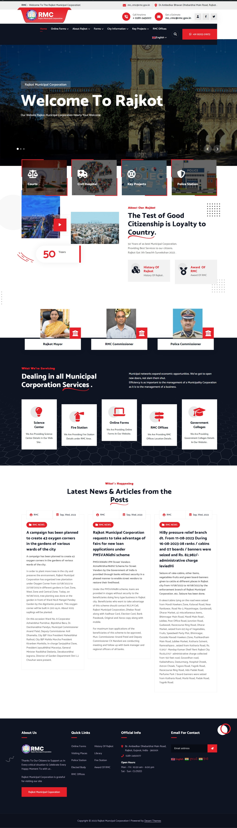

**Fig. 6.1 Home Page**

* This is Home page of Rajkot Municipal Corporation site.

**BIRTH CERTIFICATE FORM**

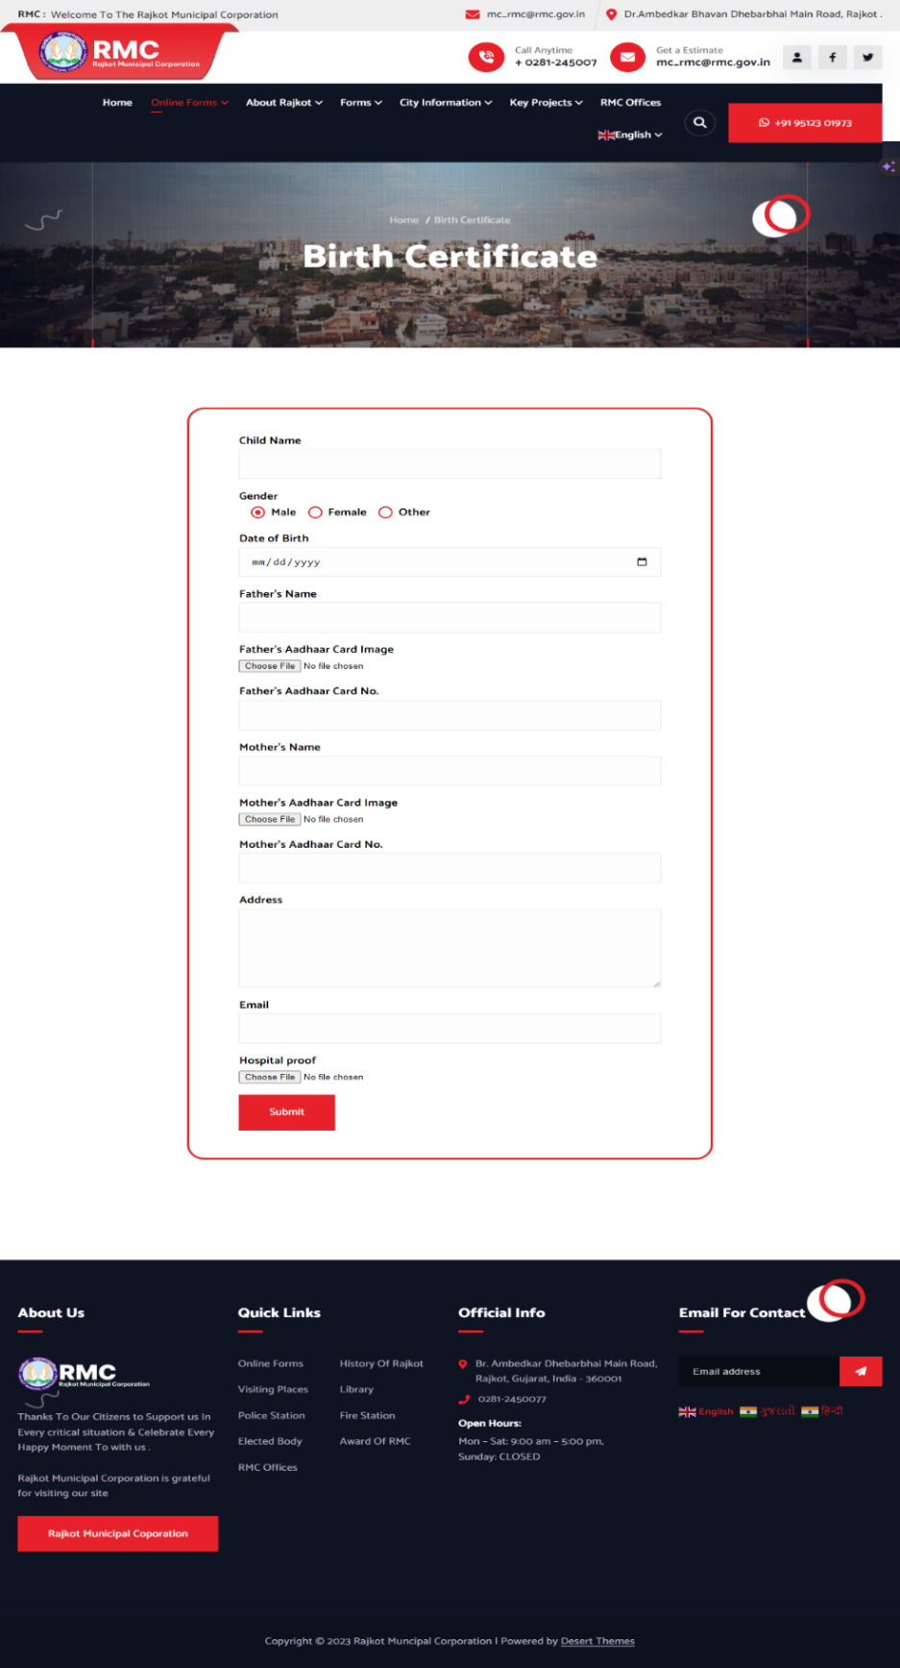

**Fig. 6.2 Birth Certificate Form**

* This is Online Form of Birth Certificate .

**BIRTH CERTIFICATE FORM RULES & REQUIRED DOCUMENTS PAGE**

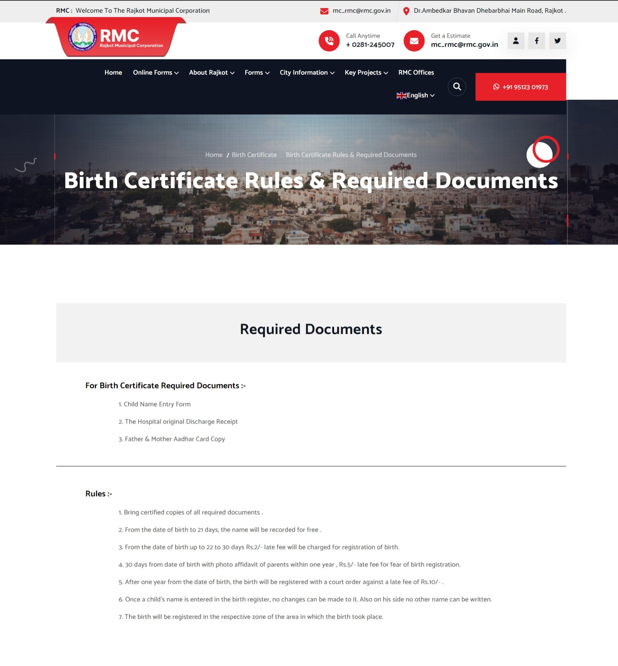

**Fig. 6.3 Birth Certificate Form Rules & Required Documents Page**

• This is the Birth Certificate rules & required documents page.

**BIRTH CERTIFICATE OFFLINE FORM**

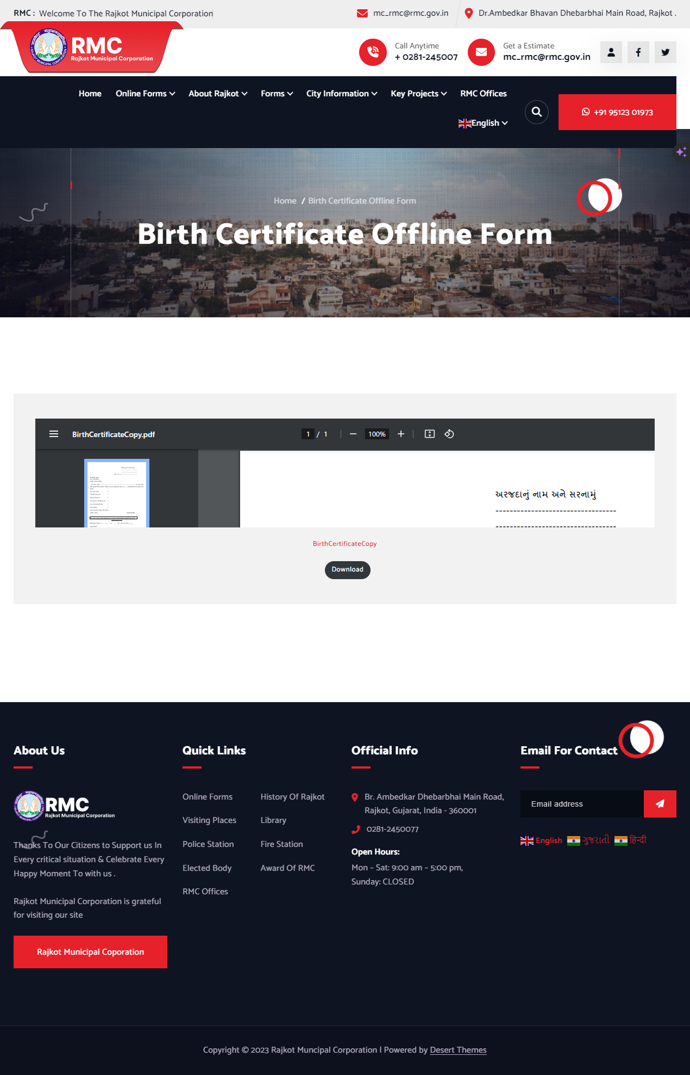

**Fig. 6.4 Birth Certificate Offline Form**

* This is Offline Form of Birth Certificate.

**PRESS RELEASE**

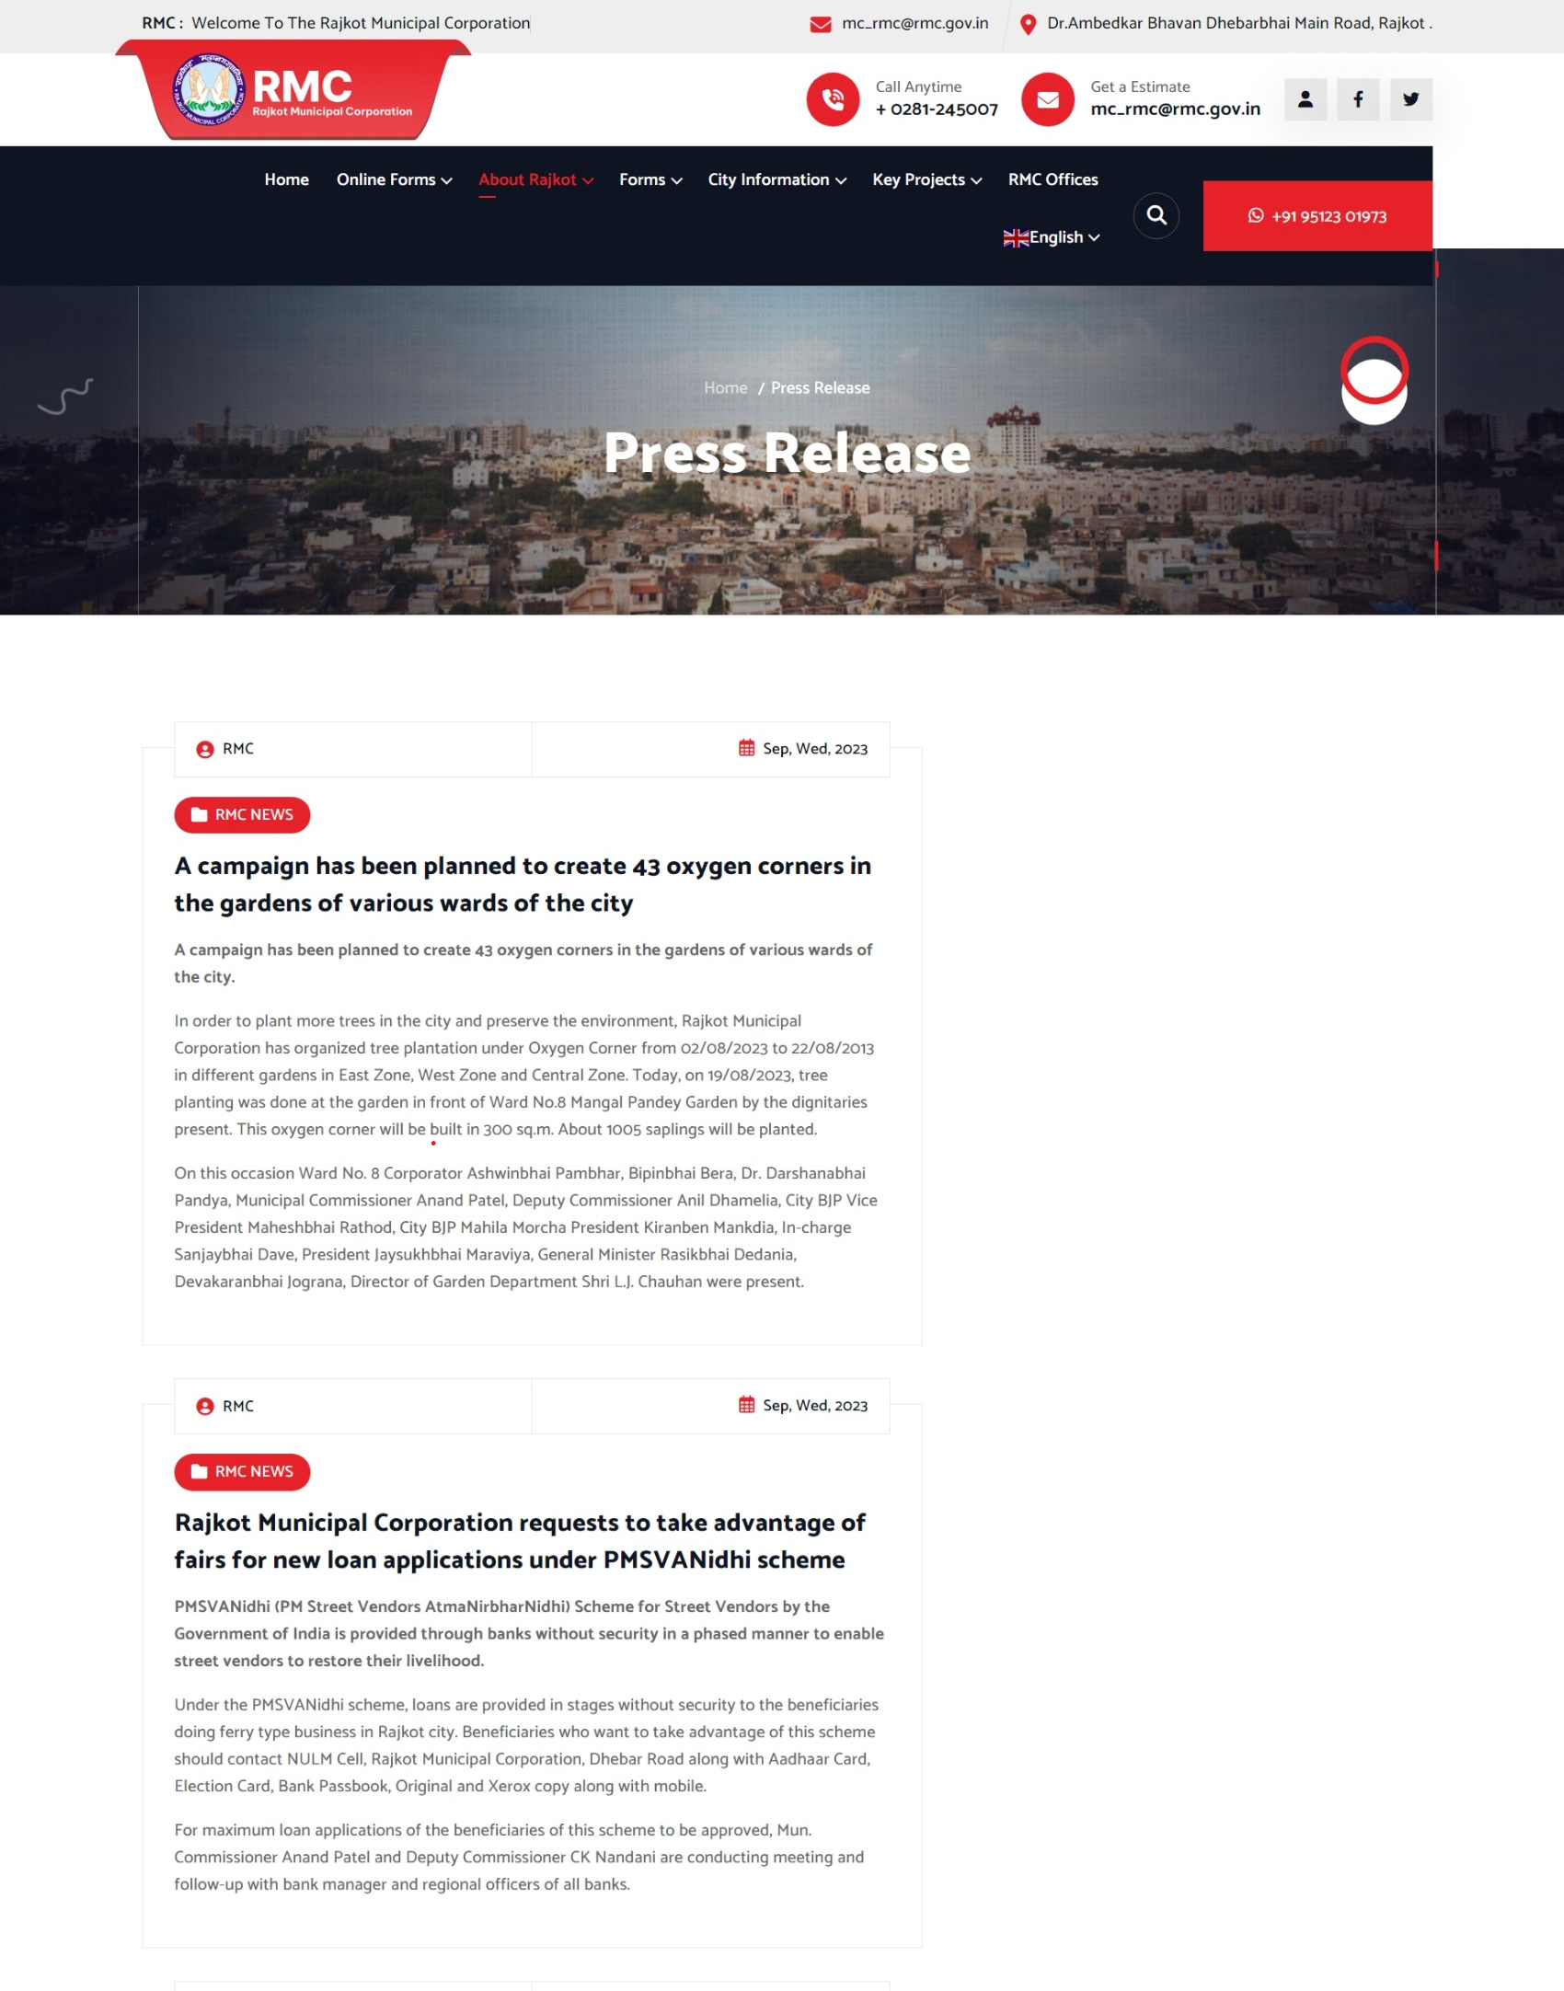

**Fig. 6.5 Press Release**

* This is Press Release Page of Rajkot Municipal Corporation.

**HISTORY OF RAJKOT**

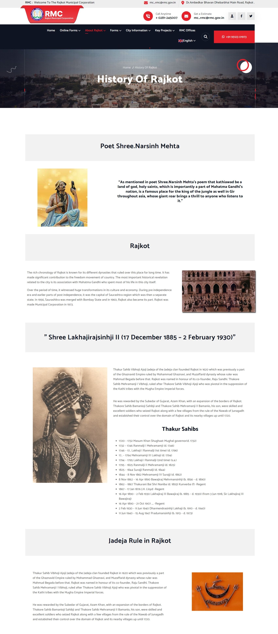

**Fig. 6.6 History of Rajkot**

* This is the History Page of Rajkot .

**ELECTED BODY**

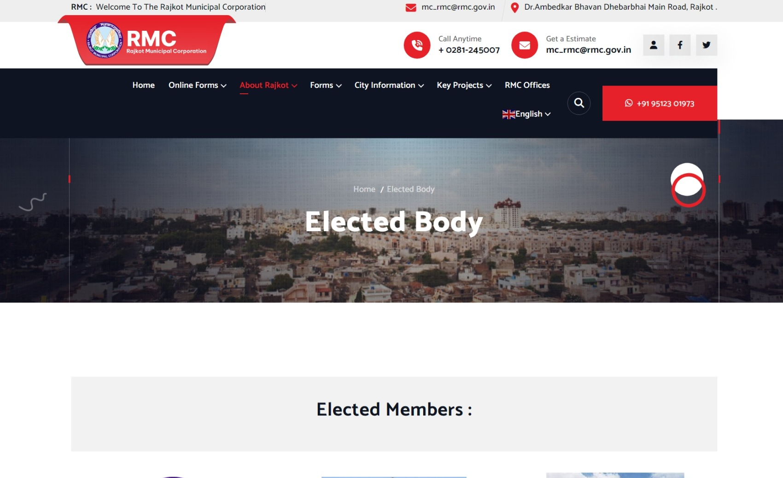

**Fig. 6.7 Elected Body**

* This is the page of Elected Body of Rajkot.

**WARD’S MEMBERS PAGE**

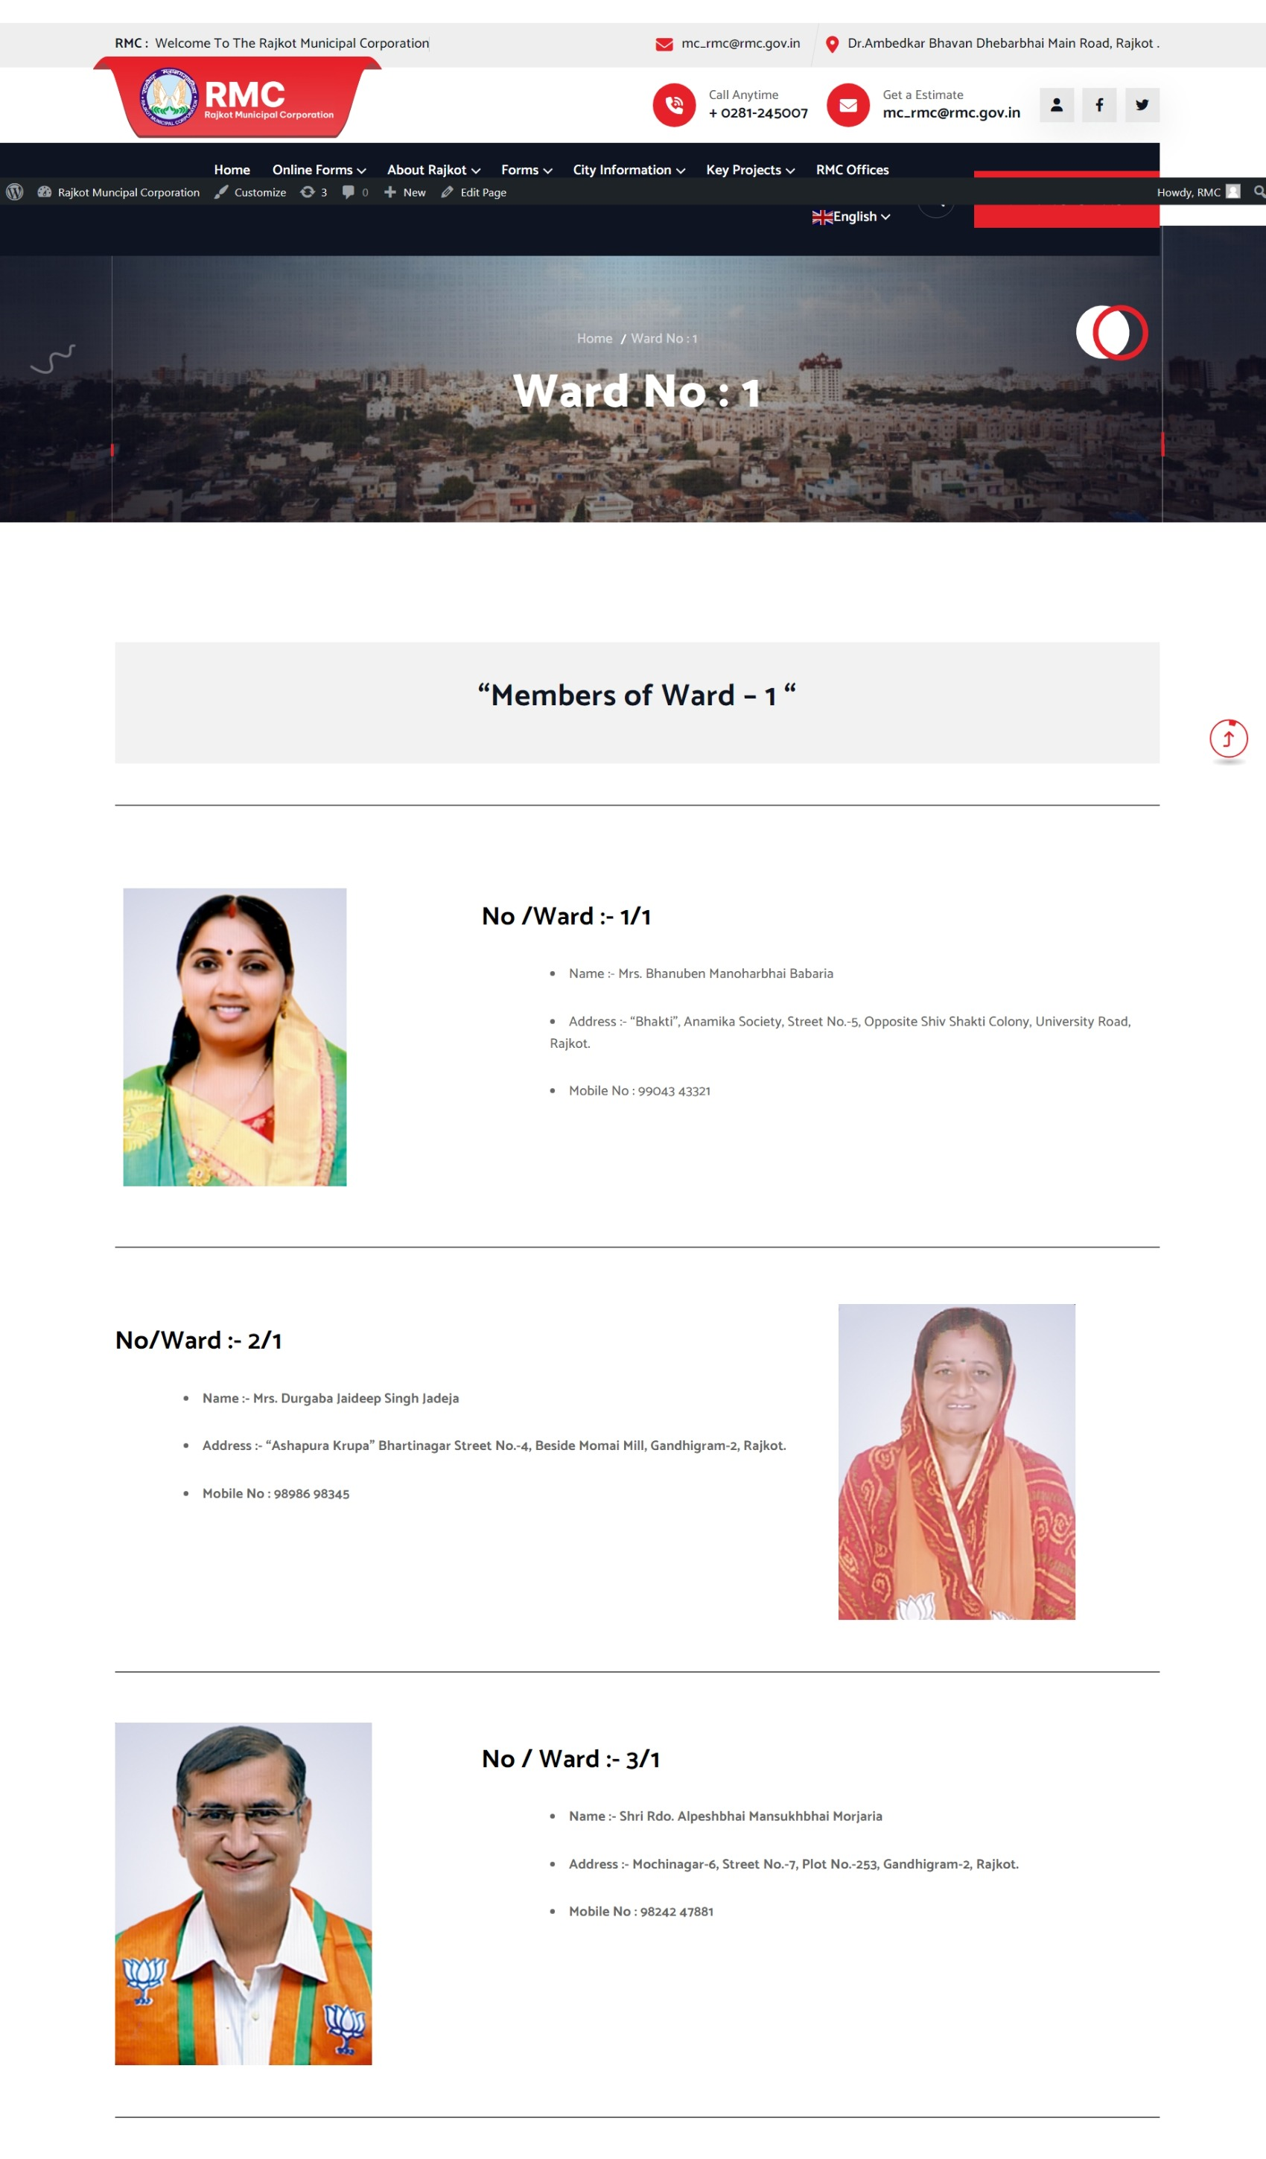

**Fig. 6.8 Ward’s Members Page**

* This is the page of Ward Members Details of Rajkot Municipal Corporation.

**VIDHAN SABHA’S MEMBERS PAGE**

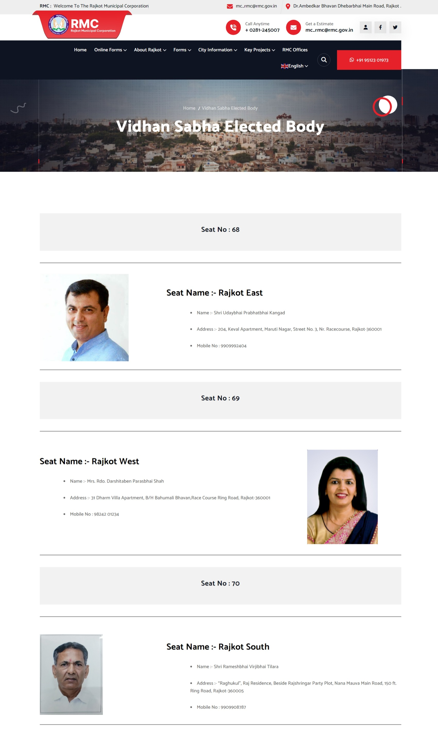

**Fig. 6.9 Vidhan Sabha’s Members Page**

* This is the page of Vidhan Sabha Members Details of Rajkot.

**LOCK SABHA’S MEMBER PAGE**

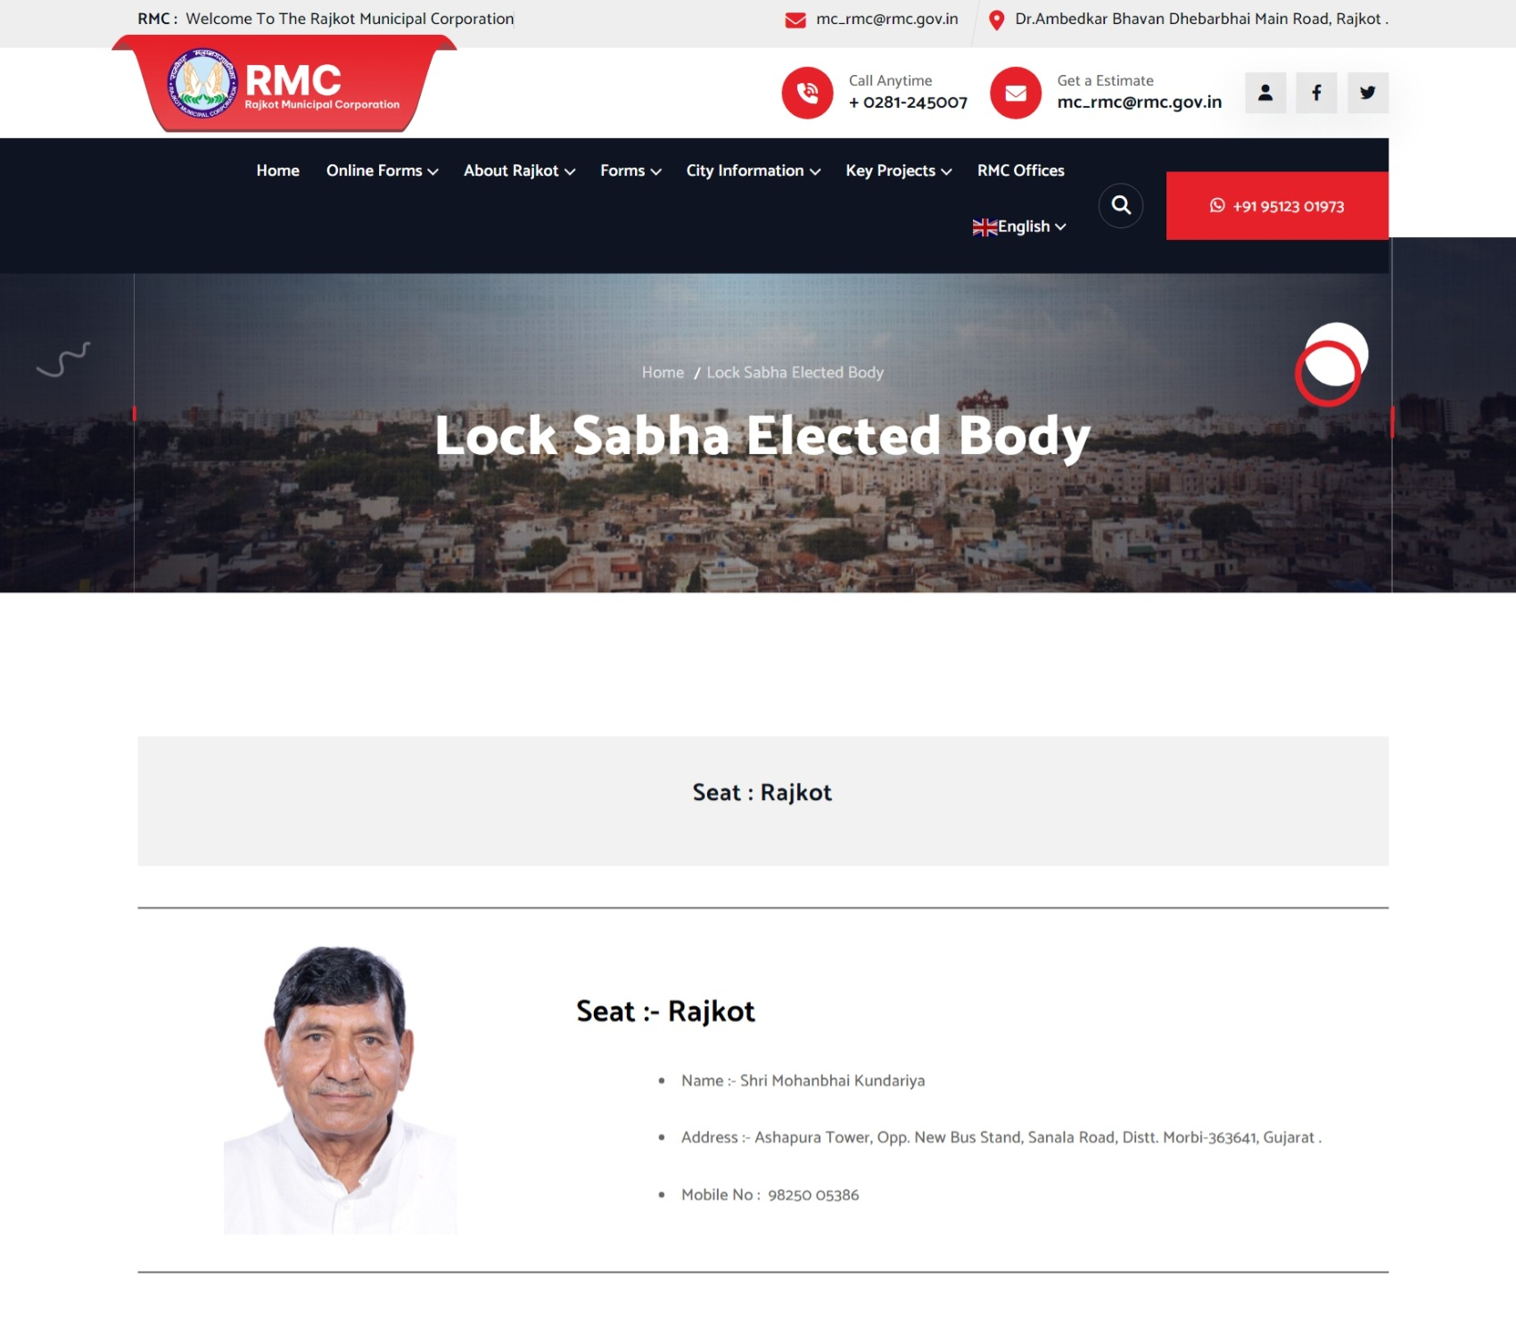

**Fig. 6.10 Lock Sabha’s Member Page**

* This is the page of Lock Sabha Member Details of Rajkot.

**AWARD OF RMC**

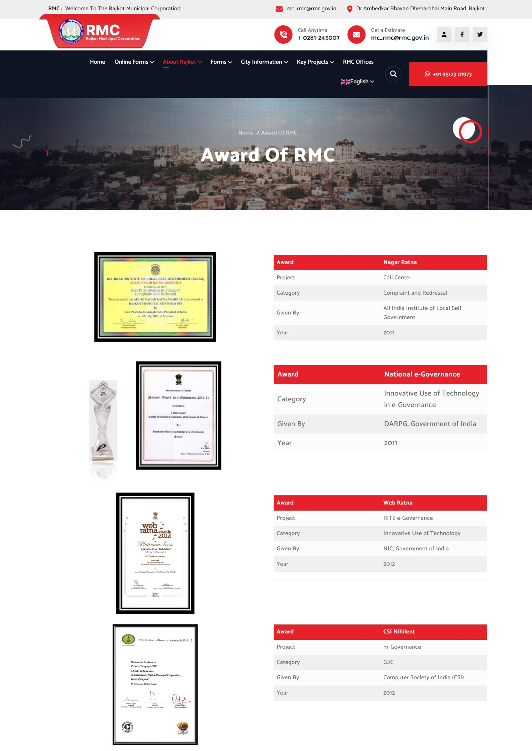

**Fig. 6.11 Award of RMC**

* This is the page of Award of Rajkot Municipal Corporation.

**PROPERTY TAX NAME TRANSFER OFFLINE FORM**

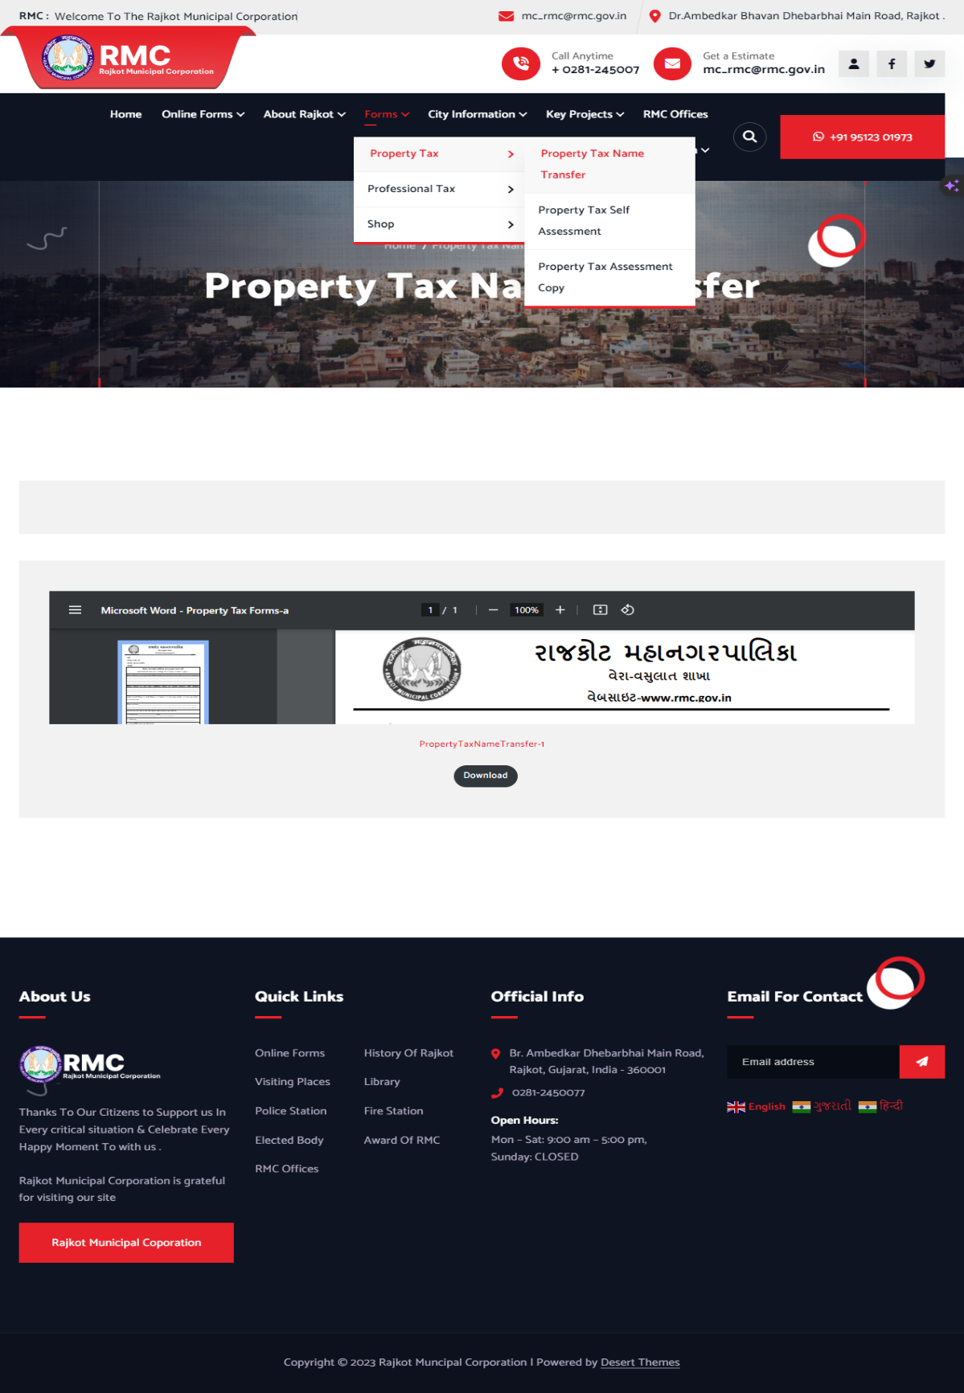

**Fig. 6.12 Property Tax Name Transfer Offline Form**

* This is the page of Offline Property Tax Name Transfer Form.

**GOVERNMENT SCHOOLS DETAILS PAGE**

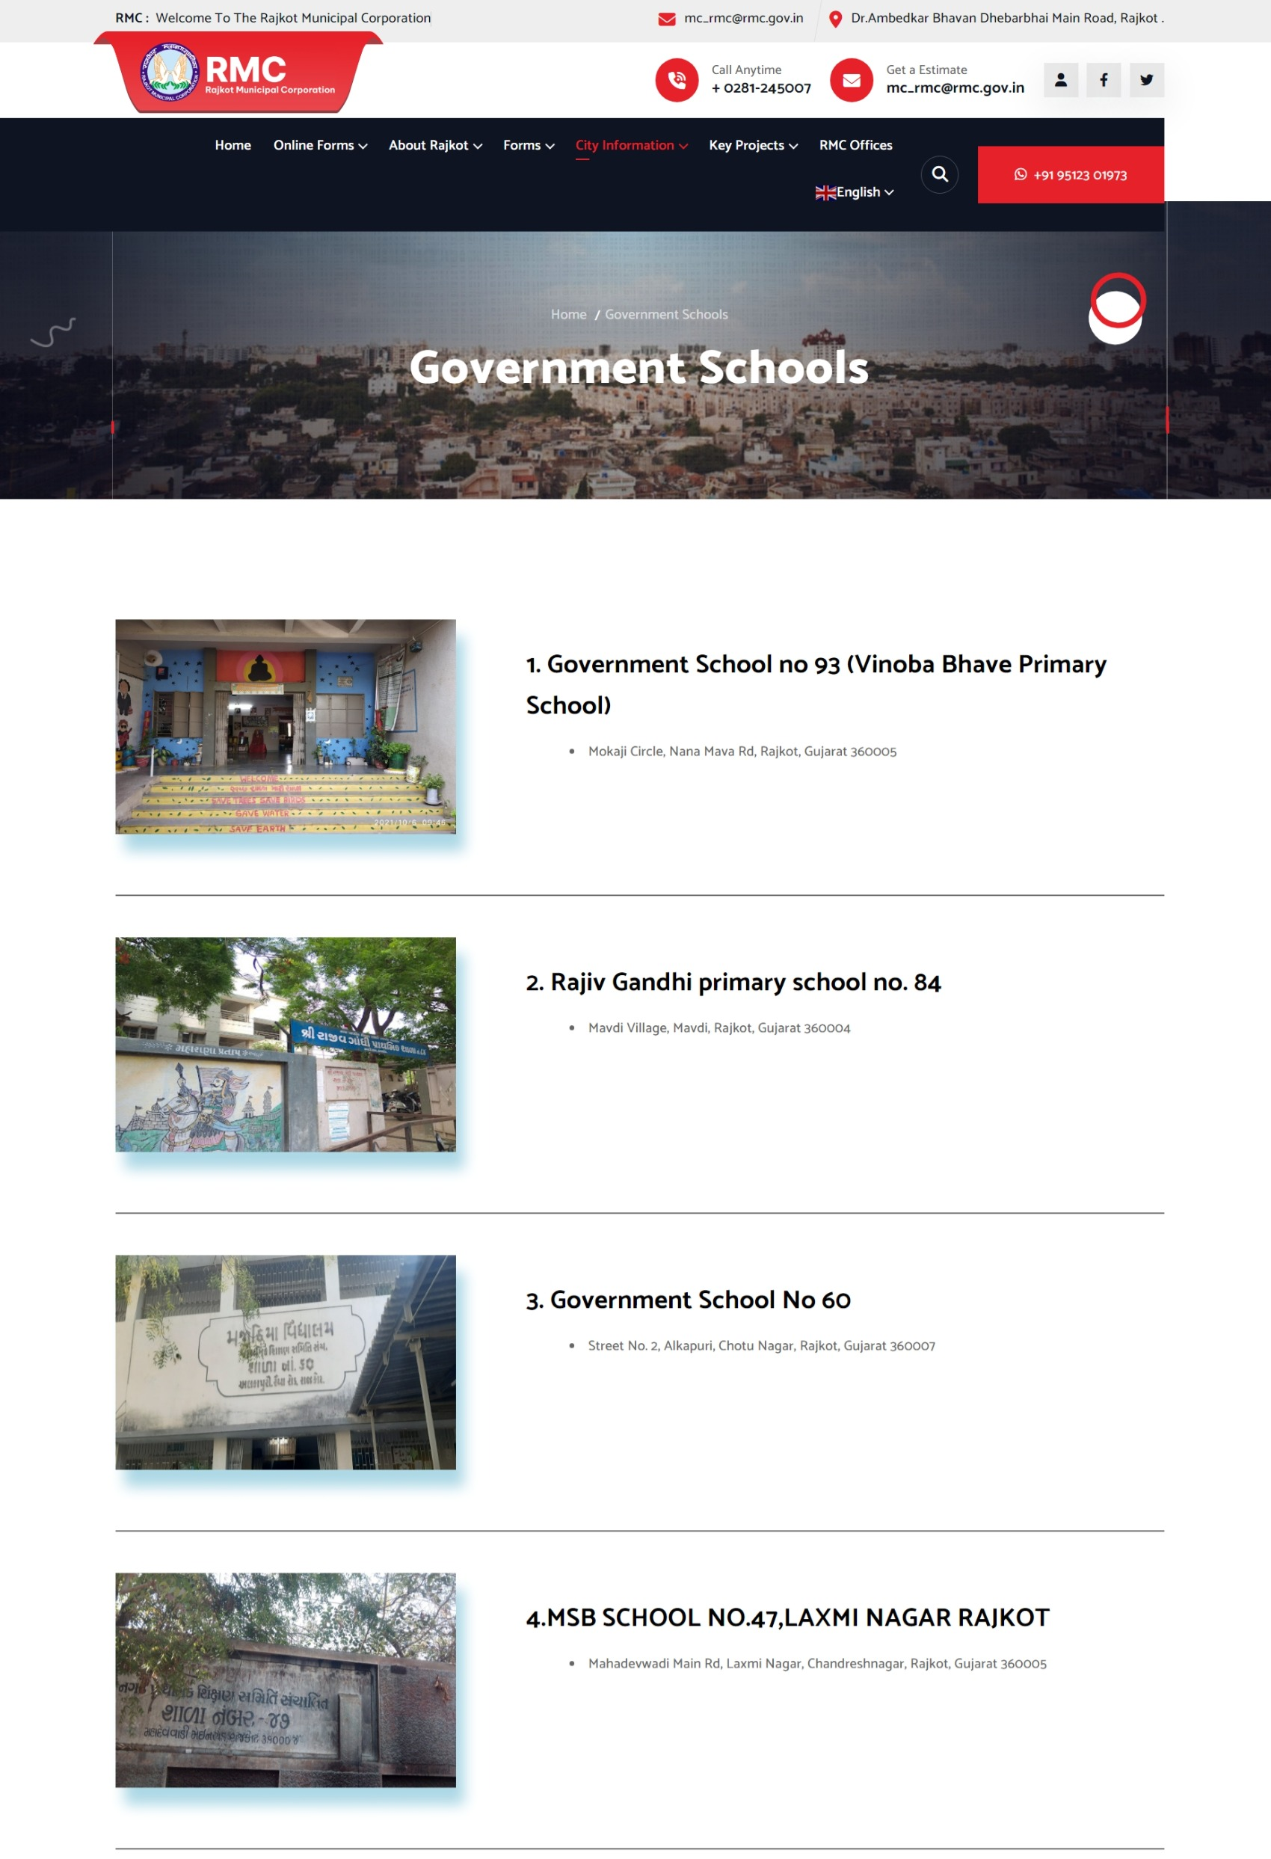

**Fig. 6.13 Government Schools Details Page**

* This is the page of Government School Details Under RMC Area.

**POLICE STATION DETAILS PAGE**

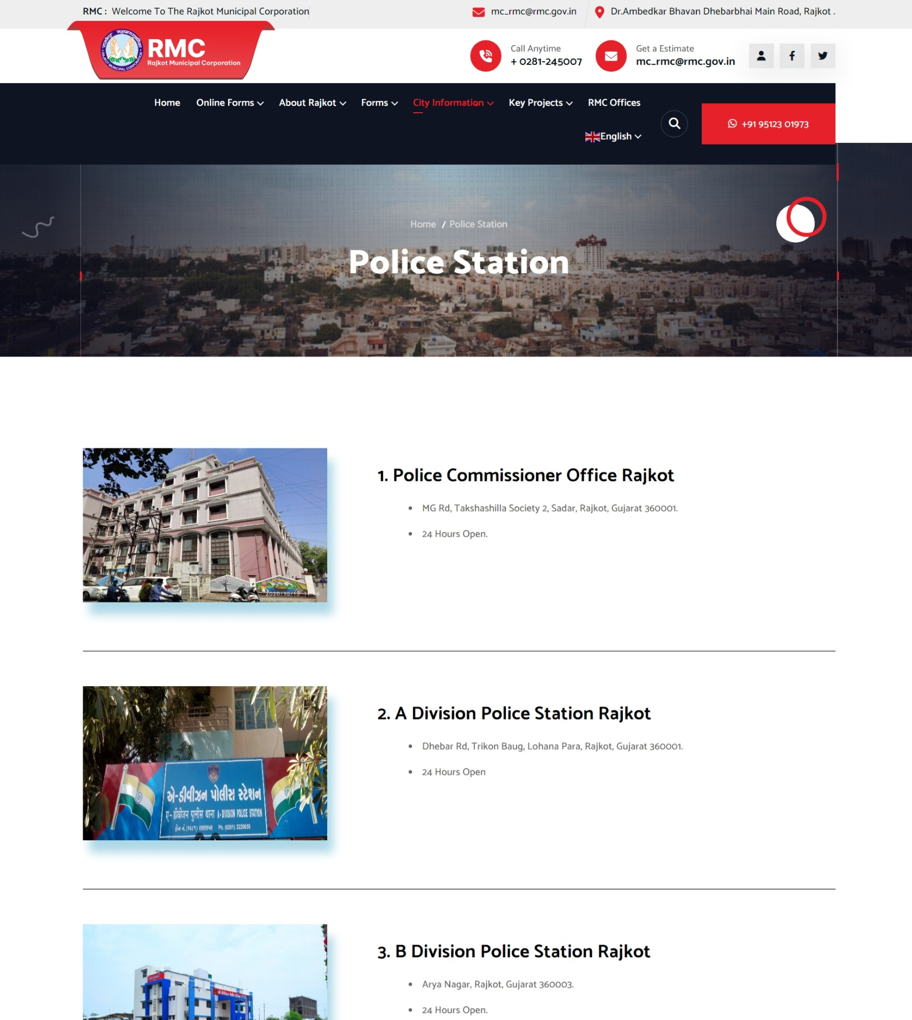

**Fig. 6.14 Police Station Details Page**

* This is the page of Police Station Details Under RMC Area.

**FIRE STATION DETAILS PAGE**

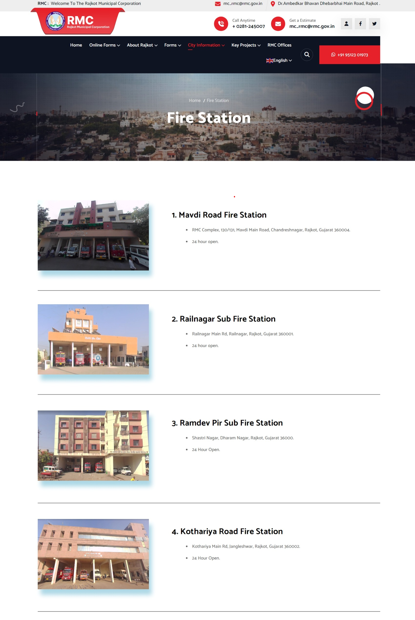

**Fig. 6.15 Fire Station Details Page**

* This is the page of Fire Station Details Under RMC Area.

**LIBRARY DETAILS PAGE**

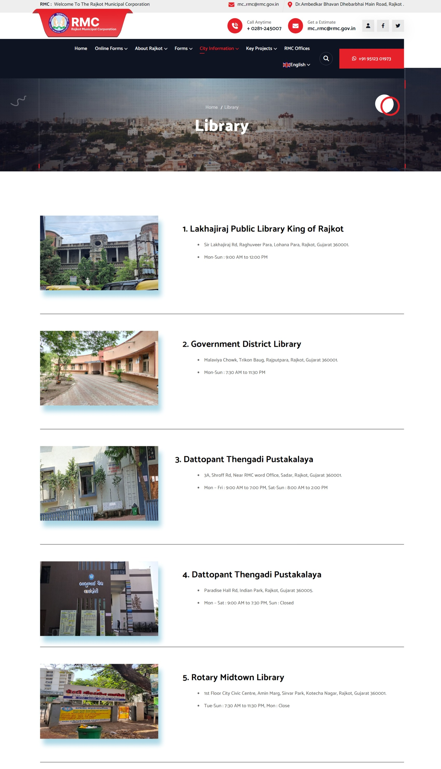

**Fig. 6.16 Library Details Page**

* This is the page of Library Details Under RMC Area.

**VISITING PLACES DETAILS PAGE**

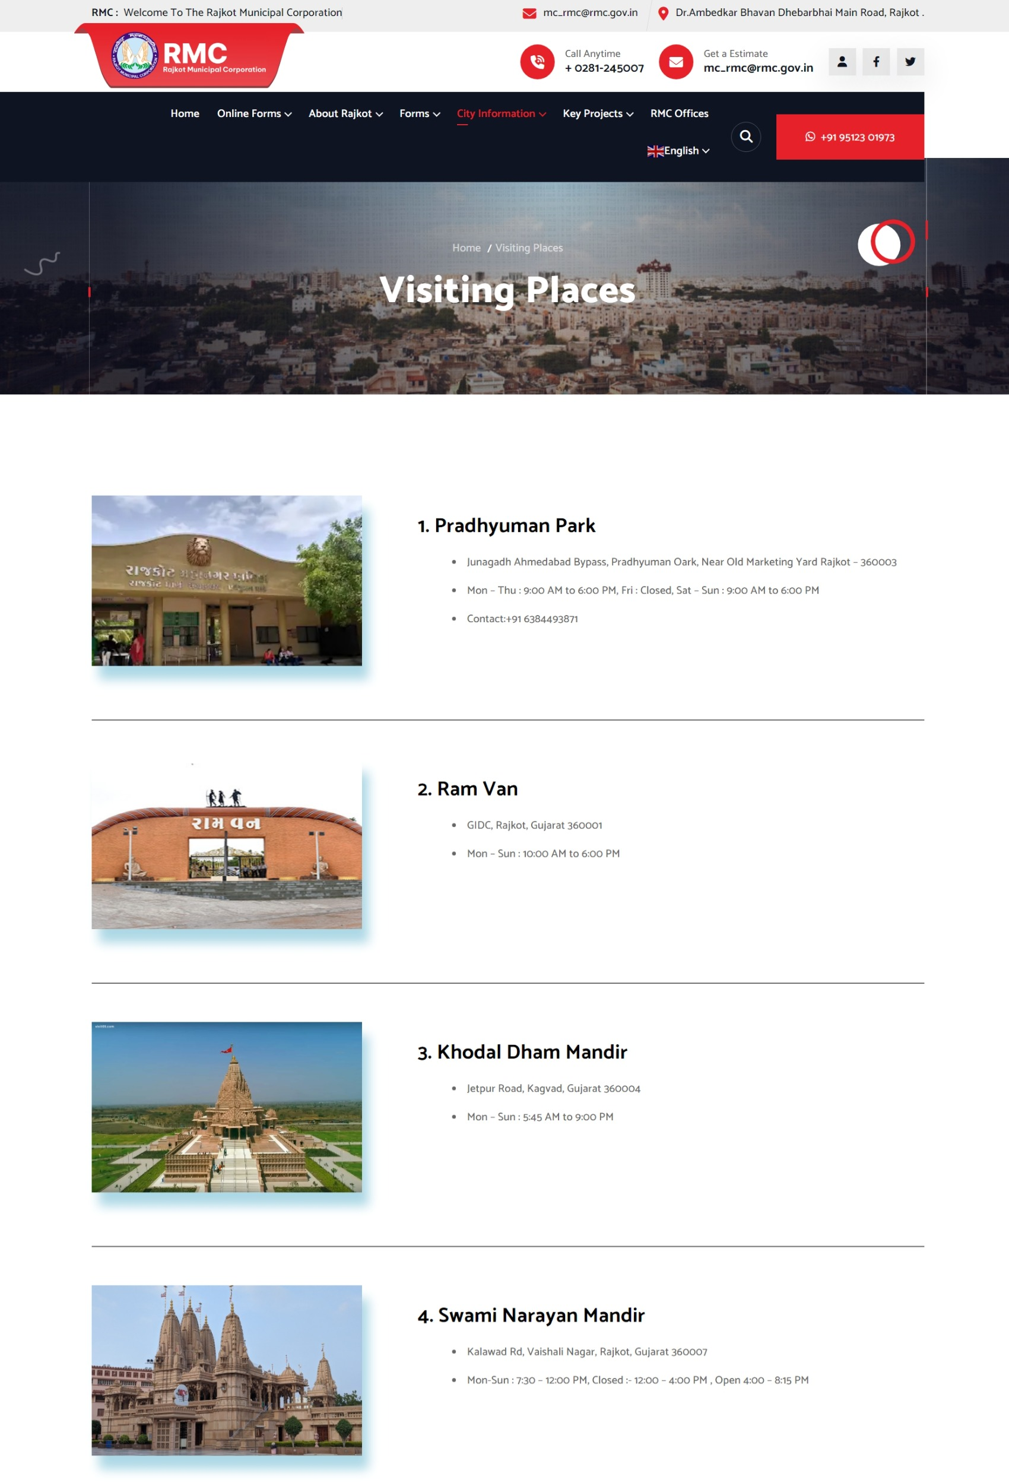

**Fig. 6.17 Visiting Places Details Page**

* This is the page of Visiting Places in Rajkot.

**KEY PROJECTS DETAILS PAGE**

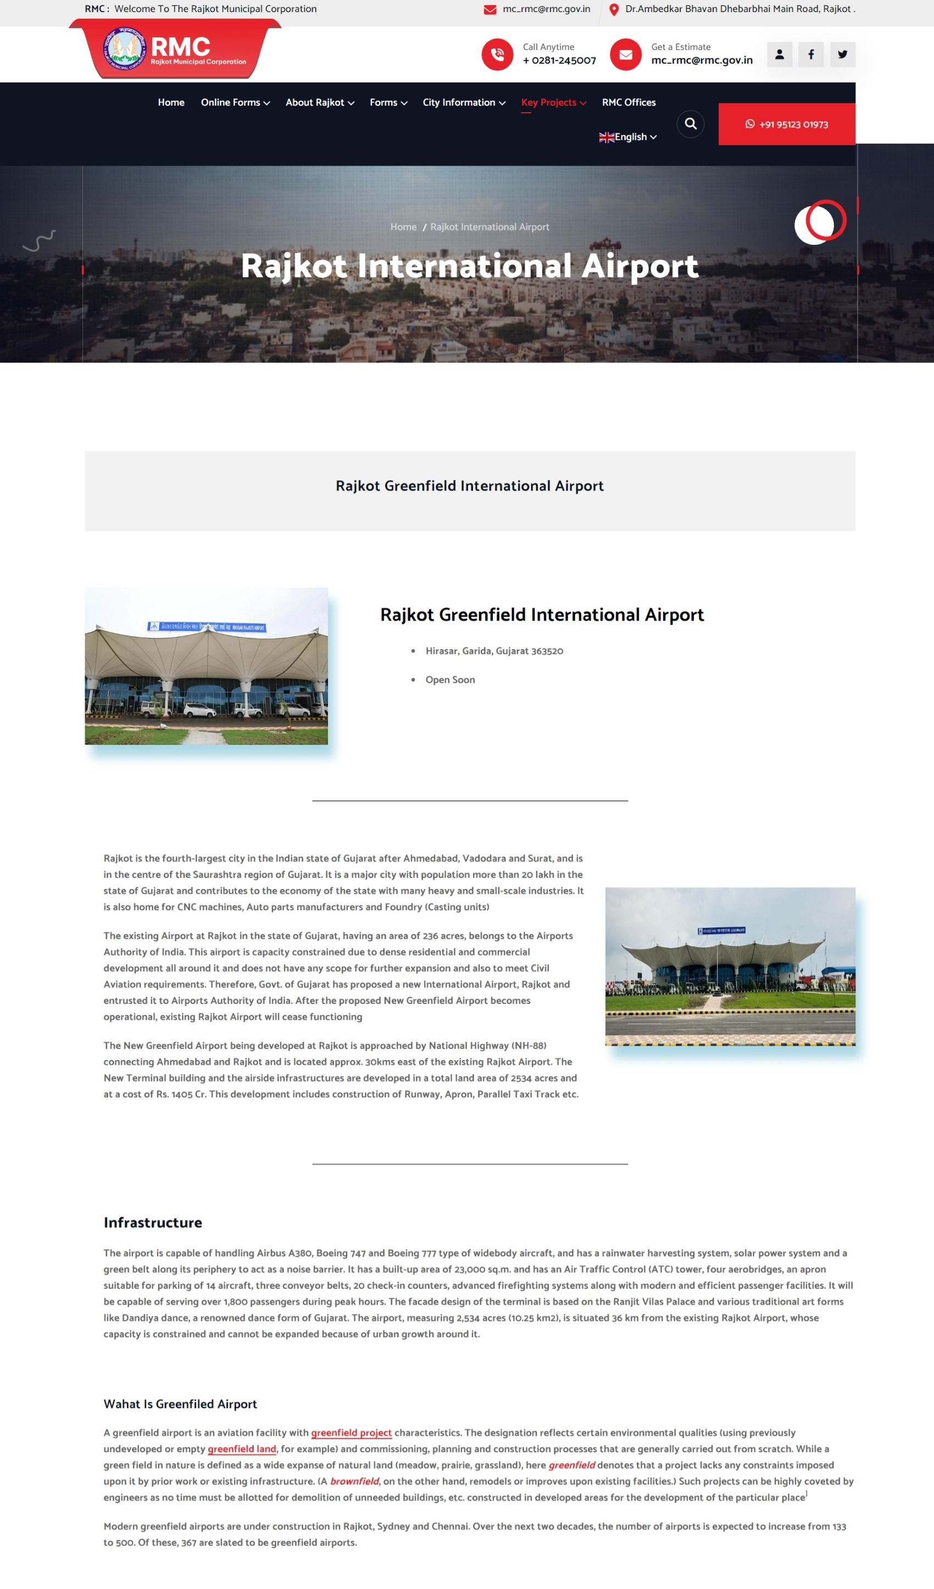

**Fig. 6.18 Key Projects Details Page**

* This is the page of Key Projects in Rajkot’s .

**RMC ZONE OFFICES DETAILS PAGE**

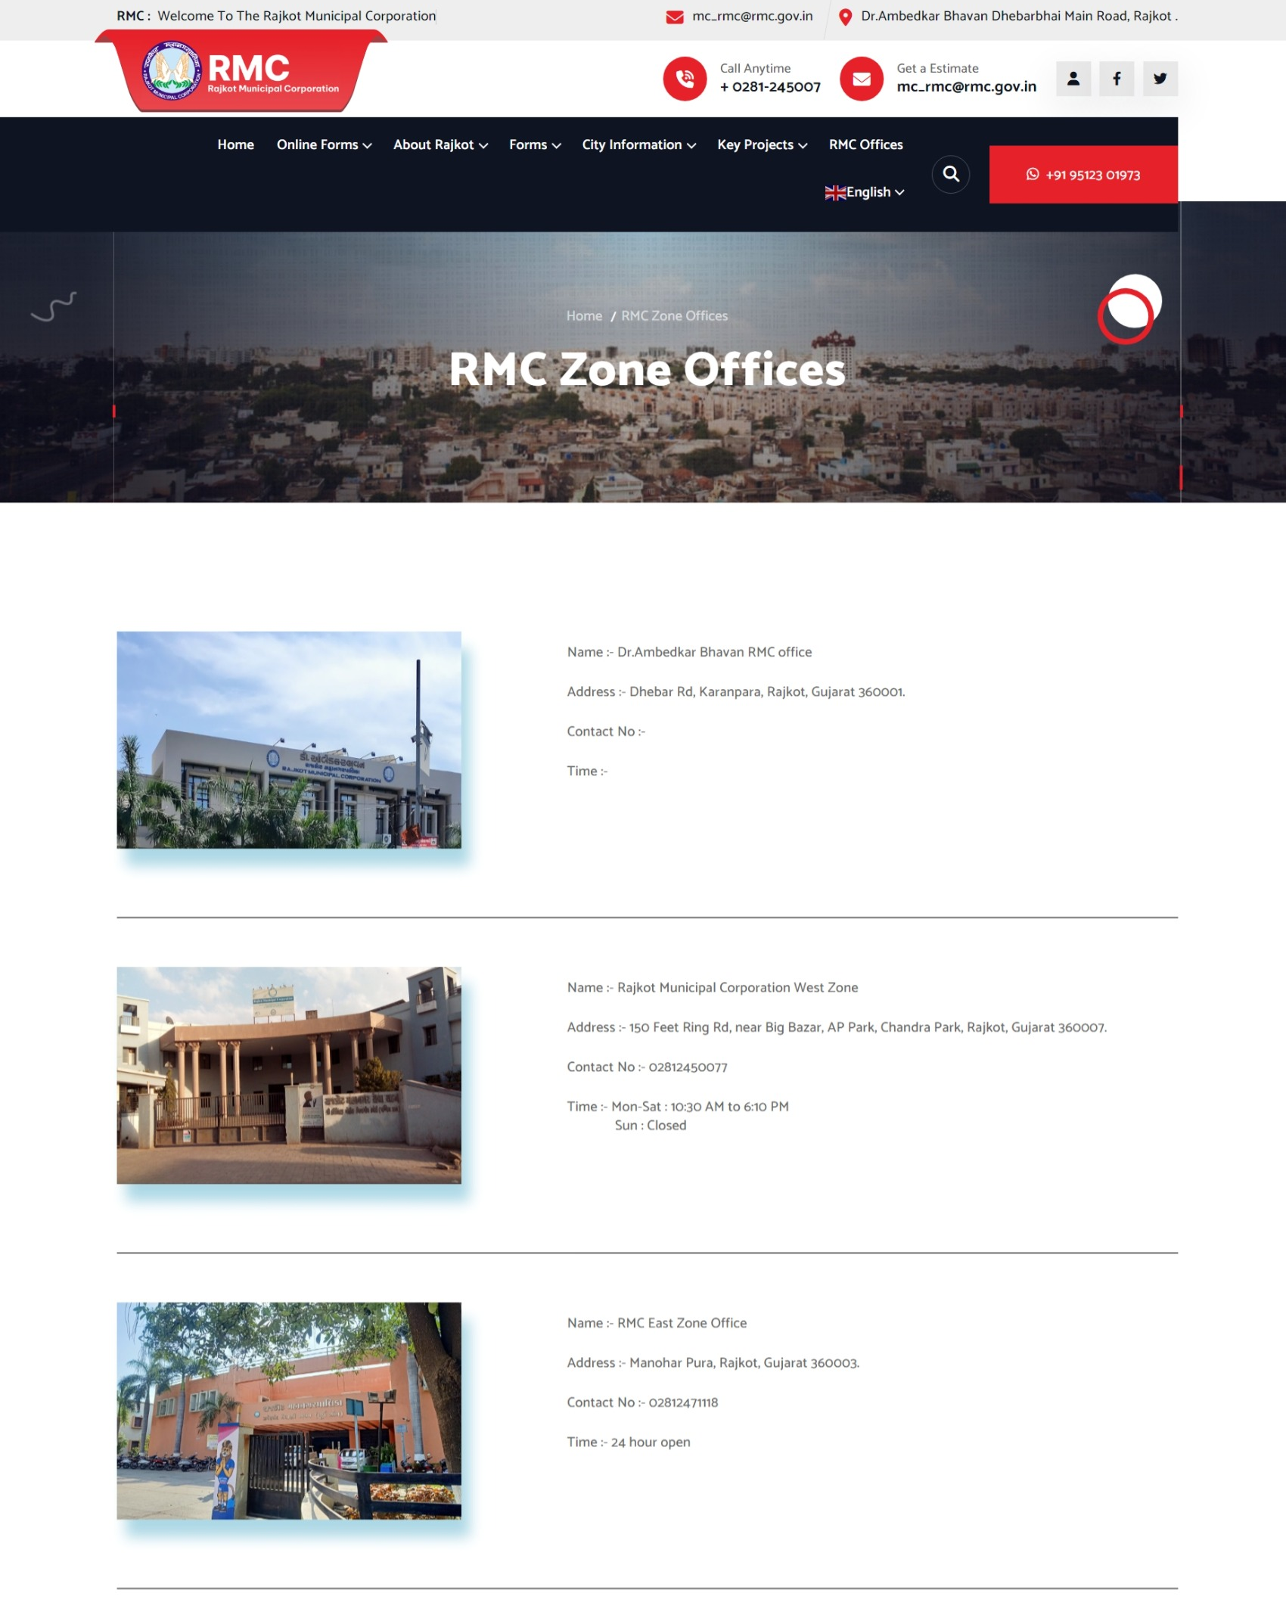

**Fig. 6.19 RMC Zone Offices Details Page**

* This is the page of RMC Zone Offices Details .

**RMC WARD OFFICES DETAILS PAGE**

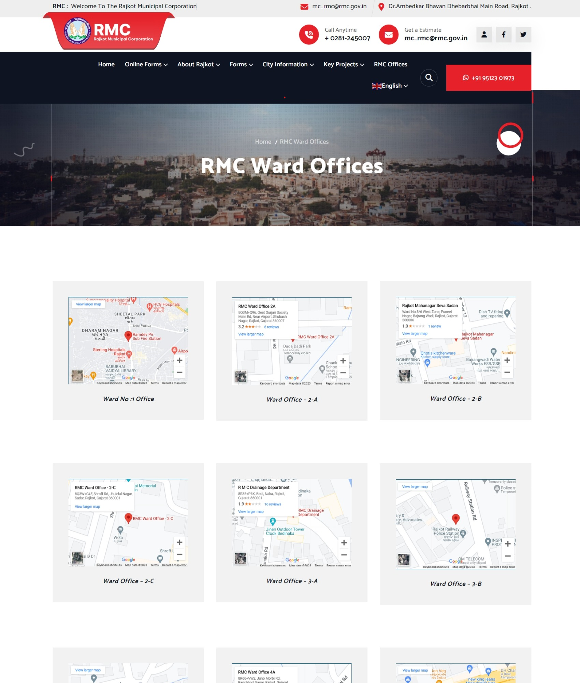

**Fig. 6.20 RMC Ward Offices Details Page**

* This is the page of RMC Ward Offices Details .

**REGISTRATION PAGE**

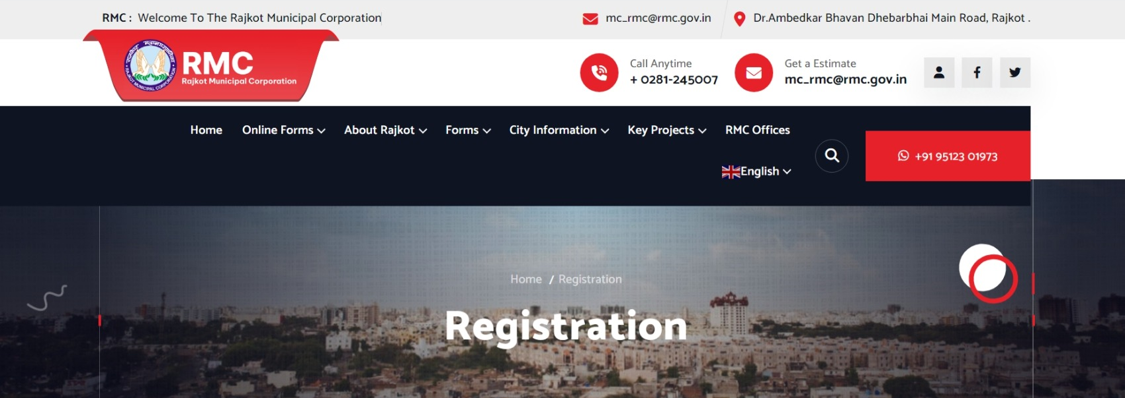

**Fig. 6.21 Registration Page**

* This is the Registration page of site .

1. **CONCLUSION**

In conclusion, the revitalization of the **Rajkot Municipal Corporation** (RMC) website is a vital step toward improving residents' lives. With a user-friendly design, mobile support, and multilingual features, online services like birth certificates, bus passes, and library passes will be easily accessible with digital receipts . Additionally, providing information on the elected body, government facilities, RMC notices, news updates, history, tax forms, key projects, and local attractions creates a one-stop resource. This transformation not only streamlines services but also encourages community involvement, transparency, and active civic engagement. The RMC's commitment to a citizen-centric website sets a positive example for effective governance, enriching the lives of its residents.

1. **FUTURE ENHANCEMENT**

In the future, we have exciting plans to enhance the RMC website further. We'll introduce online payment options for convenience and personalized user accounts to tailor information and updates to residents' preferences. Expect a helpful chat assistant for real-time support. Expanding e-government services, developing a mobile app for on-the-go access, and encouraging civic engagement through feedback platforms are all on our agenda. We're committed to inclusivity with accessibility features and multilingual support, along with social media integration for efficient communication. Smart city initiatives, IoT data, and robust feedback mechanisms will enrich the user experience. These enhancements will transform the RMC website into a more engaging and user-friendly platform, aligning with our goal of better service delivery and civic participation in the digital age.

1. **REFERENCES**

|  |  |
| --- | --- |
| **Description** | **Websites** |
| WordPress | https://www.wordpress.org |
| References | https://www.rmc.gov.in/ |
| Diagrams | https://www.draw.io.com |
| Download Theme: Softin | http://localhost/wordpress/wp-admin/themes.php?theme=softinn |
| Download Website Plugin: |  |
| **Desert Companion** | http://localhost/wordpress/wp-admin/admin.php?d**esert companion** |
| Contact Form 7 | http://localhost/wordpress/wp-admin/admin.php?page=wpcf7 |
| GTranslate | http:// http://localhost/wordpress/wp-admin/options-general.php?page=gtranslate_options |
| User Registration | http://localhost/wordpress/wp-admin/admin.php?page=user-registration-settings |
| Backup Migration | http://localhost/wordpress/wp-admin/admin.php?page=backup-migration |
| All-in-one Migration | http://localhost/wp-admin/plugin-install.php?All-in-Migration |